Dr. Rima Kumari: Date: 24/08/2020
Online class and e- content for MSc IIIrd semester Botany

Date and Time | Online class medium | E. content topic
24/08/2020  01:30 p.m to 2.30 p.m | Via Google meet  Link: Meeting URL: https://meet.google.com/fub-anwr-srg | Different types of Prokaryotes,  Bacteria and virus structure,  Eukaryotic Cell Organelles organization

Different types of Prokaryotes:
The 'group of procaryotes' is known as Monera. This group includes eubacteria, archaebacteria, green bacteria, purple bacteria, virus, prochlorophyta, cyanophyta and mycoplasma. Here we will describe the structure of two procaryotes viz. bacteria and virus.

Bacteria: Bacteria have a protective covering called 'cell wall'. Beneath this, there is a plasma membrane which encloses protoplasm of the bacterium containing various types of RNA, DNA, proteins and organic molecules. In bacteria, DNA molecule and enzymes involved in oxidation of food are found associated with the plasma membrane. Bacteria, though simple in their structure, are the most abundant of all the life forms on earth today. This is due to their rapid rate of multiplication and the ability to adapt to any nutrient and environment.

Viruses: Viruses are on the borderline of life between non-living and the living organisms. They have some characteristics of a living organism such as the ability to reproduce while some of non-living objects, like the absence of metabolic processes and ability to crystallise. Viruses are very simple organisms with a circular nucleic acid molecule (DNA or RNA) surrounded by a protein coat. Viruses are organisms which live only as parasites and can reproduce themselves only in a host cell such as bacteria, animals or plants at the expense of the metabolic machinery of the host cell.

Bacterial structure
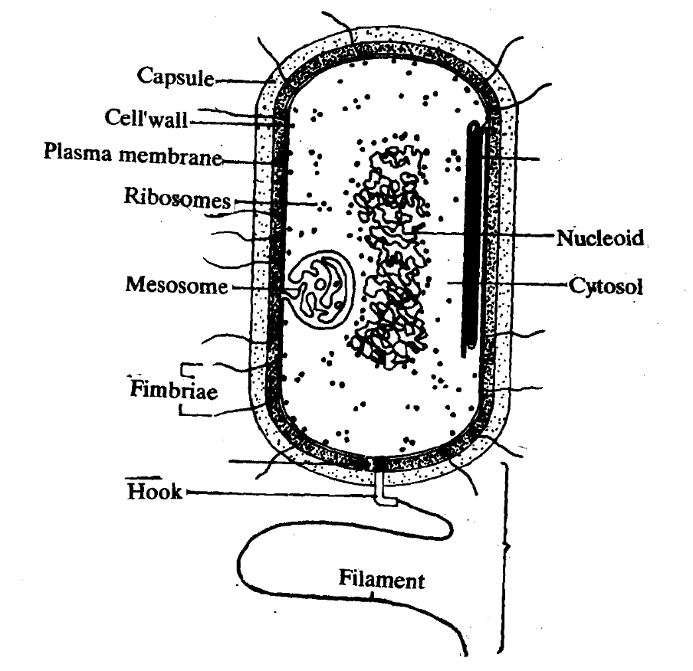
Structure of a bacterium: The bacterial cell is enclosed by a cell wall, which Is further surrounded by capsule. Infolding of plasma membrane forms mesosomes. The nuclear material is concentrated in a specific region of the cell called nucieoid. One or more flagella may be present for locomotion. Small appendages that are called flmbriae arise from the cytosol and help the bacterium in getting attached to a surface.

Bacteria single-celled prokaryotic organism (microorganisms having) the absence of the nucleus and other cell organism hence, they classified as prokaryotic organisms. A bacterial cell has five essential structural components: a nucleoid (DNA), ribosomes, cell membrane, cell wall, and some sort of surface layer, which may or may not be an inherent part of the wall. Structurally, there are three architectural regions: appendages (attachments to the cell surface) in the form of flagella and pili (or fimbriae); a cell envelope consisting of a capsule, cell wall and plasma membrane; and a cytoplasmic region that contains the cell chromosome (DNA) and ribosomes and various sorts of inclusions. Bacterial DNA are naked, independent in cytoplasm region t/a nucleoid. Great variation in size from average 1.25 µ to 2 µ diameter. Length can varied.
A bacterial cell remains surrounded by an outer layer or cell envelope, which consists of two com¬ponents – a rigid cell wall and beneath it a cyto¬plasmic membrane or plasma membrane. Bacterial cell wall is extremely thin (10-25 nm thick) and provides rigidity and a definite shape to the cell. Chemically, the cell wall is composed of mucopeptide (murein) scaffolding or platform formed by N- acetyl glucosamine and N-acetyl muramic acid mol¬ecules arranged in alternate chains. According to Peberdy (1980) the compound present in the cell walls of both Gram-negative and Gram-positive bacteria is ‘peptidoglycan’. The cell walls of Gram-positive bacteria contain up to 95% peptidoglycan and up to 10% teichoic acids. The cell envelope in some bacteria may be enclosed in a loose slimy layer or capsule.
2. Cytoplasmic membrane is a thin (5-10 nm) layer lin¬ing the inner surface of the cell wall. It separates the cell wall from the cytoplasm. It functions as a semipermeable membrane that keeps control over the inflow and outflow of metabolites to and from the protoplasm. Chemically, the cytoplasmic (plasma) membrane consists of lipoprotein with small amounts of car¬bohydrates. The lipid may reach up to 30% and protein up to 75%. Some vesicular, pocket-like structures are formed as invaginations of the cytoplasmic membrane into the cytoplasm. These are called mesosomes. They are supposed to be the principal sites of respiratory enzymes.
3. The cell encloses the protoplasm, made up of the cytoplasm, cytoplasmic inclusions (such as ribosomes, mesosomes, fat globules, inclusion bodies, vacuoles) and the nuclear material nucleoid (nacked DNA). Cytoplasm is present in the form of a colloidal system of several organic and inorganic solutes in a viscous watery solution. It does not show the protoplasmic streaming. Membrane-bound organelles, such as endoplasmic reticulum, mitochondria and Golgi- bodies are also absent in bacteria. The bacterial cytoplasm contains several ribosomes which occupy the most part of the cytoplasm. These are the centres of protein synthesis. Ribosomes are the ribonucleoprotein particles of approximately 100 Å in diameter. Intracytoplasmic inclusions are volutin, polysac¬charide, lipid, crystals and vacuoles.
4. Nuclear material is present in each bacterial cell, but there is no nuclear membrane or nucleolus. Bacteria are, therefore, prokaryotic. The low electron-density regions in the cell are actually the densely-packaged DNA regions, called ‘nuclear bodies’ or ‘nucleoids’. Nucleoid is, therefore, made up of DNA, the genetic material of the cell.
Some bacteria possess some extranucelar genetic elements made up of DNA. These cytoplasmic carriers of genetic information are called ‘plasmids’ and ‘episomes’.
5. Some bacteria also carry flagella. Flagella are long, fine, hair-like, locomotory appendages, found commonly in rod-shaped and spiral bacteria.
6. Some very fine, hair-like, surface appendages, found in some Gram-negative bacilli are called fimbriae or pili.

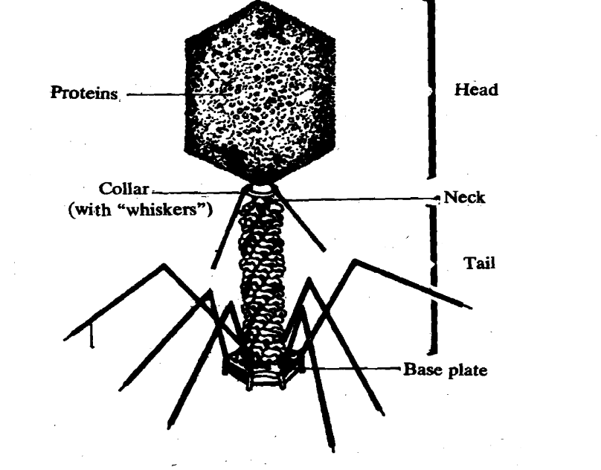
T1 bacteriophage (bacteriophage Is a specltic type of virus which kills bacteria). Six tail flbres and collar whiskers are shown in the diagram.
Viruses are boarder link between non-cellular and cellular elements that use a living cell for their replication and inactive (non living) in extracellular state. Viruses are ultramicroscopic particles containing nucleic acid surrounded by protein, and in some cases, other macromolecular components such as a membranelike envelope. A virion is complete viral structure consists of a nucleic acid core, an outer protein coating or capsid. The capsid is made up of protein subunits called capsomeres. Sometimes an outer envelope made of protein and phospholipid membranes derived from the host cell.
Viral structure. Certain viruses contain ribonucleic acid (RNA), while other viruses have deoxyribonucleic acid (DNA). The nucleic acid portion of the viruses is known as the genome. The nucleic acid may be single-stranded or double-stranded; it may be linear or a closed loop; it may be continuous or occur in segments. The genome of the virus is surrounded by a protein coat known as a capsid, which is formed from a number of individual protein molecules called capsomeres. Capsomeres are arranged in a precise and highly repetitive pattern around the nucleic acid. A single type of capsomere or several chemically distinct types may make up the capsid. The combination of genome and capsid is called the viral nucleocapsid.
A number of kinds of viruses contain envelopes. An envelope is a membrane like structure that encloses the nucleocapsid and is obtained from a host cell during the replication process. The envelope contains viral-specified proteins that make it unique. Among the envelope viruses are those of herpes simplex, chickenpox, and infectious mononucleosis.
Enveloped viruses have membranes surrounding capsids. Animal viruses, such as HIV, are frequently enveloped. Head and tail viruses infect bacteria. They have a head that is similar to icosahedral viruses and a tail shape like filamentous viruses.

Eucaryotic Cell Organelles organization
A eucaryotic cell has excessive folding of intrace!lular membrane as compared to
procaryotic cell. The eucaryotic cell has a number of'organelles such as endoplasmic
reticulum, Golgi apparatus, nucleus, mitochondria etc. Organelles have the same relation to a cell, as organs have with an organism. The endoplasmic reticulum is a complex system of membranous sacs, chambers, and tubular canals. It is the site for synthesis of proteins. The Golgi apparatus (or complex) which is a stack of flattened sacs sorts out and processes proteins, besides, it helps in secretion. Membranes also enclose lysosomes, the organelles that contain enzymes necessary for degrading foreign materials thereby help in defence mechanisms. Likewise, membranes surround peroxisomes (microbodies) in which highly reactive hydrogen peroxide is synthesised and degraded. Peroxisomes are also the sites where a variety of biochemical reactions cause conversion of lipids into proteins and vice versa.
In plants, the membranes surround large liquid filled vacuoles. The remaining cytoplasm which is not bound by these organelles is referred to as the cytosol. The extensive intracellular membrane system of a eucaryotic cell is much larger in size than a procaryotic cell. It provides enough surface area for the exchange of materials and other important cellular reactions which take place on the membrane surface. It is assumed that membranous organelles have been formed by infolding of plasma membrane through a process called endocytosis. In endocytosis portions of cell membrane along with the contents of the external medium invaginate and pinch off in the form of cytoplasmic vesicles. Exocytosis is just a reverse process.
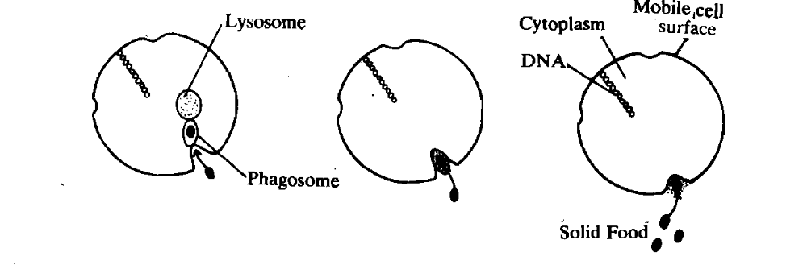
Endocytosis was the possible mechanism for ingestion of food to prevent damage to internal cell components. Endocytotic pockets were located on the outer surface of the cell.
b) In later stages of evolution, food was packaged in the membranous vesicles formed mecelle surface which also induced the digestive enzymes The food was digested outside the cell in specialised enclosures.
c) In the last stages of evolution, the digestive enzymes were packaged in lysosomes located internally and food was digested by the fusion of lysosome and phagosome vesicles, a physiological process, well known in the present day cell.

All eucaryotic cells have a cytoskeleton made up of a network of protein filaments. This network gives the cell its shape, capacity to move and ability to transport organelles from one part of a cell to another. These protein filaments are similar in all eucaryotes. The important protein filaments are-actin and myosin in muscles and tubulin in microtubules. Actin and myosin are involved in muscle contraction and in the formation of microfilaments. Microtubules are hollow ~d form cilia, flagella, centriole and mitotic spindle. This kind of cytoskeleton is absent in the procaryotes.
In eucaryotes it is enclosed inside the nucleus. This kind of formation of compartment protects DNA from many chemical changes that occur in the cytoplasm. The DNA found in eucaryote is not only large (human cells contain DNA thousand times larger than that in a typical bacteria) but is also packed together with histones into / chromosomes. Histones are the proteins which are basic in nature, found in eucaryotes/They bind to DNA and wrap it up into compact chromosomes. Histones also-control the expression of the characters called gene expression. Histones are important proteins which have nbt undergone any change during evolution and are identical in all plant and animal cells studied so far. Division of the nucleus by mitosis is another characteristic of the eucaryotes which permits proper and equal distribution of the genetic material to the daugher cells. Ribosomes which are the
granular structures consisting of RNA and proteins are necessary for protein synthesis. These are the only organelles that are common to both procaryotes and eucaryotes.

