THE IMPORTANCE OF FACIAL CHANGES AND PHYSICAL CHANGES IN EMOTION

Emotion

Emotion is often defined as a complex state of feeling that results in physical and psychological changes that influence thought and behavior. It is psychological phenomena, including temperament, personality, mood, and motivation.
संवेग को अक्सर भावना की एक जटिल स्थिति के रूप में परिभाषित किया जाता है जिसके परिणामस्वरूप शारीरिक और मनोवैज्ञानिक परिवर्तन होते हैं जो विचार और व्यवहार को प्रभावित करते हैं। यह स्वभाव, व्यक्तित्व, मनोदशा और प्रेरणा सहित मनोवैज्ञानिक घटनाएं हैंI

Theories of Emotion
The major theories of emotion can be grouped into three main categories: physiological, neurological, and cognitive.
- Physiological theories suggest that responses within the body are responsible for emotions.
- Neurological theories propose that activity within the brain leads to emotional responses.
- Cognitive theories argue that thoughts and other mental activity play an essential role in forming emotions.

Evolutionary Theory of Emotion
It was naturalist Charles Darwin who proposed that emotions evolved because they were adaptive and allowed humans and animals to survive and reproduce. Feelings of love and affection lead people to seek mates and reproduce. Feelings of fear compel people to either fight or flee the source of danger.

The James-Lange Theory of Emotion
The James-Lange theory is one of the best-known examples of a physiological theory of emotion. Independently proposed by

psychologist William James and physiologist Carl Lange, the

James-Lange theory of emotion suggests that emotions occur as a result of physiological reactions to events. We fear because we tremble to see snake.

The Cannon-Bard Theory of Emotion
.Cannon first proposed his theory in the 1920s, and his work was later expanded on by physiologist Philip Bard during the 1930s.
According to the Cannon-Bard theory of emotion, we feel
emotions and experience physiological reactions such as
sweating, trembling, and muscle tension simultaneously.
The theory proposes that emotions result when the thalamus sends a message to the brain in response to a stimulus, resulting in a physiological reaction. At the same time, the brain also receives signals triggering the emotional experience. Cannon and Bard’s theory suggests that the physical and psychological experience of emotion happen at the same time and that one does not cause the other.

Schachter-Singer Theory
Also known as the two-factor theory of emotion, the Schachter-Singer theory is an example of a cognitive theory of emotion. This

theory suggests

that the physiological arousal occurs first, and then the individual must
identify the reason for this arousal to experience and label it as an emotion. A stimulus leads to a physiological response that is then cognitively interpreted and labeled, resulting in an emotion.
Schachter and Singer’s theory draws on both the James-Lange theory and the Cannon-Bard theory. Like the James-Lange theory, the Schachter-Singer theory proposes that people infer emotions based on physiological responses. The critical factor is the situation and the cognitive interpretation that people use to label that emotion.
Like the Cannon-Bard theory, the Schachter-Singer theory also suggests that similar physiological responses can produce varying emotions. For example, if you experience a racing heart and sweating palms during an important exam, you will probably identify the emotion as anxiety. If you experience the same physical responses on a date, you might interpret those responses as love, affection, or arousal.

Cognitive Appraisal Theory ( Richard Lazarus Theory)
According to appraisal theories of emotion, thinking must occur first before experiencing emotion. Richard Lazarus was a pioneer in this area of emotion, and this theory is often referred to as the Lazarus theory of emotion.
According to this theory, the sequence of events first involves a stimulus, followed by thought, which then leads to the simultaneous experience of a physiological response and the emotion. For example, if you encounter a bear in the woods, you might immediately begin to think that you are in great danger. This then leads to the emotional experience of fear and the physical reactions associated with the fight-or-flight response.
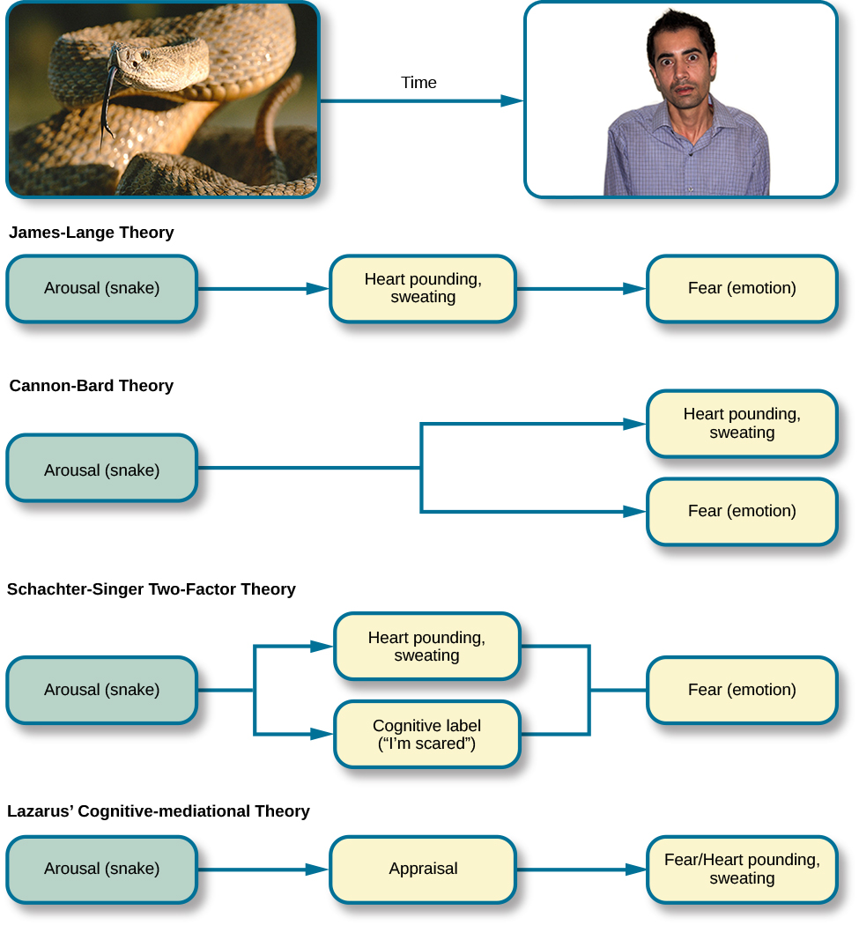

FACIAL CHANGES IN EMOTION
Emotions changes the blood flow in our faces.
- Through this colour changes, people can be picked up on.
- People can correctly identify someone's emotions from these colour changes up to 75% of the time.
- Being "blue in the face" with anger could hold more truth than just being an old idiom
"Not only do we perceive these changes in facial color, but we use them to correctly identify how other people are feeling, whether we do it consciously or not."

Happiness was the most easily identifiable emotion, with the computer identifying it with 90% accuracy.
Emotions related to happiness, like "happily surprised," came second at around 85%,
Anger at 80%, and
Sadness at 75%.
"Fearfully disgusted" was the least recognisable, which was correctly identified 65% of the time
. Red, green, blue, and yellow in different amounts and locations can characterise nearly every emotion, according to the research.
Disgust is generally experienced by a blue-yellow colour around the lips, and red-green around the nose and forehead.
A smiling person with red cheeks and temples, with a little blue around the chin, is "happy,
But a slightly redder forhead and slightly less blue chin is characterised as "surprised."
संवेग हमारे चेहरे में रक्त के प्रवाह को बदल देती हैं।
इस रंग परिवर्तन के माध्यम से, लोगों को उठाया जा सकता है।
75% समय तक लोग इन रंग परिवर्तनों से किसी की भावनाओं को सही ढंग से पहचान सकते हैं।
क्रोध के साथ "चेहरे में नीला" होना एक पुराने मुहावरे की तुलना में अधिक सत्य हो सकता है
"न केवल हम चेहरे के रंग में इन परिवर्तनों को देखते हैं, बल्कि हम उनका उपयोग सही ढंग से पहचानने के लिए करते हैं कि दूसरे लोग कैसा महसूस कर रहे हैं, चाहे हम इसे होशपूर्वक करते हैं या नहीं।"
खुशी सबसे आसानी से पहचानी जाने वाली भावना थी, कंप्यूटर ने इसे 90% सटीकता के साथ पहचाना।
खुशी से संबंधित भावनाएँ, जैसे "हैप्पी सरप्राइज़", लगभग 85% के साथ दूसरे स्थान पर रहीं,
80% पर गुस्सा, और
75% पर उदासी।
"भयभीत रूप से घृणित" सबसे कम पहचानने योग्य था, जिसे 65% समय में सही ढंग से पहचाना गया था
. शोध के अनुसार, लाल, हरा, नीला और पीला अलग-अलग मात्रा और स्थानों में लगभग हर भावना की विशेषता हो सकती है।
घृणा आमतौर पर होठों के चारों ओर नीले-पीले रंग और नाक और माथे के चारों ओर लाल-हरे रंग से होती है।
लाल गाल और मंदिरों वाला एक मुस्कुराता हुआ व्यक्ति, ठोड़ी के चारों ओर थोड़ा नीला, "खुश" है,
लेकिन थोड़ा लाल सिर और थोड़ी कम नीली ठुड्डी को "आश्चर्यचकित" कहा जाता है।

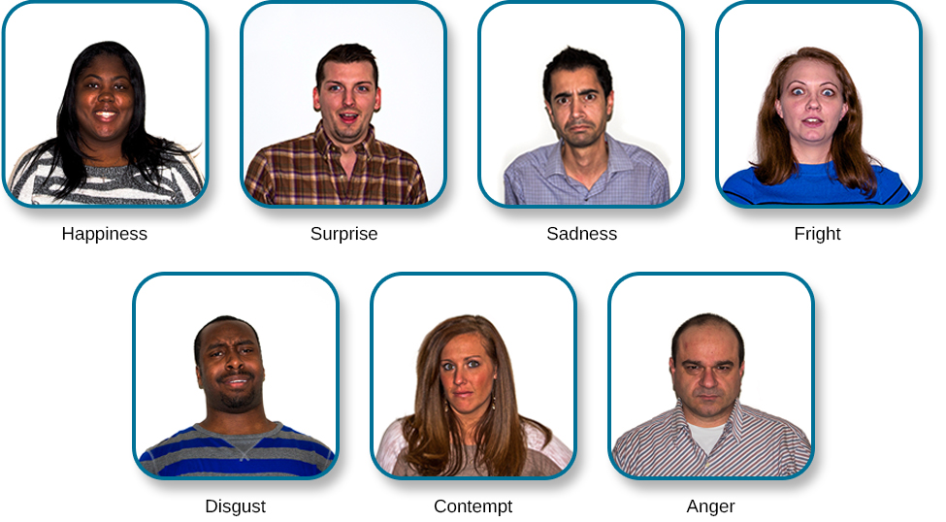
PHYSICAL CHANGES IN EMOTION
The most obvious signs of emotional arousal involve changes in the activity of the visceral motor (autonomic) system .
Thus, increases or decreases in heart rate,
cutaneous blood flow (blushing or turning pale),
piloerection, sweating, and gastrointestinal motility can all accompany various emotions.
These responses are brought about by changes in activity in the sympathetic,
parasympathetic, and
enteric components of the visceral motor system, which govern smooth muscle, cardiac muscle, and glands throughout the body..
As Cannon pointed out, “The desire for food and drink, the relish of taking them, all the pleasures of the table are naught in the presence of anger or great anxiety.”
Activation of the visceral motor system, particularly the sympathetic division, was long considered an all-or-nothing process. Once effective stimuli engaged the system, it was argued, a widespread discharge of all of its components ensued.
The responses of the autonomic nervous system are actually quite specific, with different patterns of activation characterizing different situations and their associated emotional states.
Indeed, emotion-specific expressions produced voluntarily can elicit distinct patterns of autonomic activity. For example, if subjects are given muscle-by-muscle instructions that result in facial expressions recognizable as anger, disgust, fear, happiness, sadness, or surprise without being told which emotion they are simulating, each pattern of facial muscle activity is accompanied by specific and reproducible differences in visceral motor activity
One interpretation of these findings is that when voluntary facial expressions are produced, signals in the brain engage not only the motor cortex but also some of the circuits that produce emotional states. Perhaps this relationship helps explain how good actors can be so convincing.
Sympathetic nervous system and parasympathetic nervous system
The sympathetic division initiates the fight-or-flight response and the parasympathetic initiates the rest-and-digest or feed-and-breed responses. The sympathetic and parasympathetic nervous systems are important for modulating many vital functions, including respiration and cardiac contractility.

The motor cortex is the region of the cerebral cortex involved in the planning, control, and execution of voluntary movements. Classically, the motor cortex is an area of the frontal lobe located in the posterior precentral gyrus immediately anterior to the central sulcus.
- Hypothalamus. In addition to controlling emotional responses, the hypothalamus is also involved in sexual responses, hormone release, and regulating body temperature.
- Hippocampus. The hippocampus helps preserve and retrieve memories. It also plays a role in how you understand the spatial dimensions of your environment.
- Amygdala. The amygdala helps coordinate responses to things in your environment, especially those that trigger an emotional response. This structure plays an important role in fear and anger.
- Limbic cortex. This part contains two structures, the cingulate gyrus and the parahippocampal gyrus. Together, they impact mood, motivation, and judgement.

भावनात्मक उत्तेजना के सबसे स्पष्ट संकेतों में आंत की मोटर (स्वायत्त) प्रणाली की गतिविधि में परिवर्तन शामिल हैं।
इस प्रकार, हृदय गति में वृद्धि या कमी होती है,
त्वचीय रक्त प्रवाह (शरमाना या पीला पड़ना),
तीक्ष्णता, पसीना और जठरांत्र संबंधी गतिशीलता सभी विभिन्न भावनाओं के साथ हो सकते हैं।
इन प्रतिक्रियाओं को सहानुभूति में गतिविधि में परिवर्तन के द्वारा लाया जाता है,
पैरासिम्पेथेटिक, औरआंत की मोटर प्रणाली के आंतों के घटक, जो पूरे शरीर में चिकनी पेशी, हृदय की मांसपेशियों और ग्रंथियों को नियंत्रित करते हैं।
जैसा कि कैनन ने बताया, "खाने और पीने की इच्छा, उन्हें लेने का स्वाद, मेज के सभी सुख क्रोध या बड़ी चिंता की उपस्थिति में शून्य हैं।"
आंत की मोटर प्रणाली का सक्रियण, विशेष रूप से सहानुभूति विभाजन, लंबे समय से एक सर्व-या-कुछ भी प्रक्रिया नहीं माना जाता था। एक बार प्रभावी उत्तेजनाओं ने सिस्टम को शामिल कर लिया, यह तर्क दिया गया कि इसके सभी घटकों का व्यापक निर्वहन हुआ।
स्वायत्त तंत्रिका तंत्र की प्रतिक्रियाएं वास्तव में काफी विशिष्ट होती हैं,
वास्तव में, स्वेच्छा से उत्पन्न भावना-विशिष्ट अभिव्यक्तियाँ स्वायत्त गतिविधि के अलग-अलग पैटर्न प्राप्त कर सकती हैं। उदाहरण के लिए, यदि विषयों को पेशी-दर-मांसपेशियों के निर्देश दिए जाते हैं जिसके परिणामस्वरूप चेहरे के भाव क्रोध, घृणा, भय, खुशी, उदासी या आश्चर्य के रूप में पहचाने जाते हैं, बिना यह बताए कि वे किस भावना का अनुकरण कर रहे हैं, चेहरे की मांसपेशियों की गतिविधि के प्रत्येक पैटर्न आंत की मोटर गतिविधि में विशिष्ट और प्रतिलिपि प्रस्तुत करने योग्य अंतर को नियंत्रित करते हैं।

इन निष्कर्षों की एक व्याख्या यह है कि जब स्वैच्छिक चेहरे के भाव उत्पन्न होते हैं, तो मस्तिष्क में संकेत न केवल मोटर प्रांतस्था को जोड़ते हैं बल्कि कुछ ऐसे सर्किट भी होते हैं जो भावनात्मक स्थिति उत्पन्न करते हैं। शायद यह रिश्ता यह समझाने में मदद करता है कि अच्छे अभिनेता कितने आश्वस्त हो सकते हैं।

सहानुभूति तंत्रिका तंत्र और पैरासिम्पेथेटिक तंत्रिका तंत्र
सहानुभूति विभाजन लड़ाई-या-उड़ान प्रतिक्रिया शुरू करता है और पैरासिम्पेथेटिक आराम-और-पाचन या फ़ीड-एंड-नस्ल प्रतिक्रियाओं की शुरुआत करता है। सहानुभूति और पैरासिम्पेथेटिक तंत्रिका तंत्र श्वसन और हृदय संकुचन सहित कई महत्वपूर्ण कार्यों को संशोधित करने के लिए महत्वपूर्ण हैं।

मोटर कॉर्टेक्स स्वैच्छिक आंदोलनों की योजना, नियंत्रण और निष्पादन में शामिल सेरेब्रल कॉर्टेक्स का क्षेत्र है। शास्त्रीय रूप से, मोटर कॉर्टेक्स ललाट लोब का एक क्षेत्र है जो केंद्रीय खांचे के ठीक पूर्वकाल में पश्च प्रीसेंट्रल गाइरस में स्थित होता है।
• हाइपोथैलेमस। भावनात्मक प्रतिक्रियाओं को नियंत्रित करने के अलावा, हाइपोथैलेमस यौन प्रतिक्रियाओं, हार्मोन रिलीज और शरीर के तापमान को नियंत्रित करने में भी शामिल है।
• हिप्पोकैम्पस। हिप्पोकैम्पस यादों को संरक्षित और पुनः प्राप्त करने में मदद करता है। यह इस बात में भी भूमिका निभाता है कि आप अपने पर्यावरण के स्थानिक आयामों को कैसे समझते हैं।
• अमिगडाला। अमिगडाला आपके वातावरण में चीजों की प्रतिक्रियाओं को समन्वित करने में मदद करता है, विशेष रूप से वे जो भावनात्मक प्रतिक्रिया को ट्रिगर करते हैं। यह संरचना भय और क्रोध में महत्वपूर्ण भूमिका निभाती है।
• लिम्बिक कॉर्टेक्स। इस भाग में दो संरचनाएं होती हैं, सिंगुलेट गाइरस और पैराहिपोकैम्पल गाइरस। साथ में, वे मूड, प्रेरणा और निर्णय को प्रभावित करते हैं।

Brain Structures

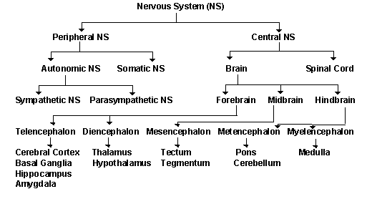

Cerebral Cortex
Functions:
- Thought
- Voluntary movement
- Language
- Reasoning
- Perception
The word "cortex" comes from the Latin word for "bark" (of a tree). This is because the cortex is a sheet of tissue that makes up the outer layer of the brain. The thickness of the cerebral cortex varies from 2 to 6 mm. The right and left sides of the cerebral cortex are connected by a thick band of nerve fibers called the "corpus callosum." In higher mammals such as humans, the cerebral cortex looks like it has many bumps and grooves. A bump or bulge on the cortex is called a gyrus (the plural of the word gyrus is "gyri") and a groove is called a sulcus (the plural of the word sulcus is "sulci"). Lower mammals, such as rats and mice, have very few gyri and sulci.
Cerebellum
Functions:
- Movement
- Balance
- Posture
The word "cerebellum" is derived from the Latin word for "little brain." Located behind the brain stem, the cerebellum is similar to the cerebral cortex because it has hemispheres and a cortex that surrounds the hemispheres.
Brain stem
Functions: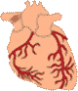
- Breathing
- Heart Rate
- Blood Pressure
The brain stem refers to the area of the brain between the thalamus and spinal cord. Structures of the brain stem include the pons, medulla oblongta, tectum, reticular formation and tegmentum. The brain stem is important for maintaining basic life functions such as breathing, heart rate and blood pressure.
Hypothalamus
Functions:
- Body Temperature
- Emotions
- Hunger
- Thirst
- Circadian Rhythms
The hypothalamus is composed of several different areas and is located at the base of the brain. The hypothalamus is only 1/300 of the total brain weight. One function of the hypothalamus is the control of body temperature. The hypothalamus detects changes in body temperature and sends commands to adjust the temperature. For example, the hypothalamus can detect fever and respond by sending a command to expand capillaries in the skin. The expansion of the capillaries cools the blood and results in a drop in body temperature. The hypothalamus also controls the pituitary.
Thalamus
Functions:
- Sensory processing
- Movement
The thalamus receives sensory information from other areas of the nervous system and sends this information to the cerebral cortex. The thalamus is also important for processing information related to movement.
Limbic System
Functions:
- Emotions
- Memory
The limbic system (or the limbic areas) is a group of structures that includes the amygdala, the hippocampus, mammillary bodies and cingulate gyrus. These areas are important for controlling the emotional response to a given situation. The hippocampus is also important for memory.
Hippocampus
Functions:
- Learning
- Memory
The hippocampus is one part of the limbic system that is important for memory and learning.
Basal Ganglia
Functions:
- Movement
The basal ganglia are a group of structures, including the globus pallidus, caudate nucleus, subthalamic nucleus, putamen and substantia nigra, that are important in coordinating movement.
Midbrain
Functions:
- Vision
- Audition
- Eye Movement
- Body Movement
The midbrain includes structures such as the superior and inferior colliculi and red nucleus. There are several other areas also in the midbrain.
Now that you have read about the areas of the brain, take a look at where these areas are located:
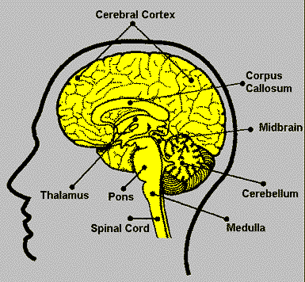

The End

