Dr. Rima Kumari: Date: 05/08/2020
Online class and e- content for BSc IInd year students
Date and Time | Online class medium | E. content topic
05/08/2020  02:45 p.m to 3.40 p.m | Via Google meet  Link: Meeting URL: https://meet.google.com/zsg-qozj-ava | Modifications in Mendel’s rules

Modifications in Mendel’s rules in case of single genes
Some of the variations on Mendel’s rules involve single genes. These include:
Incomplete dominance. Mendel’s results were groundbreaking partly because studies shows the contradicted results in some cases. Two alleles may produce an intermediate phenotype when both are present, rather than one fully determining the phenotype. The phenotype of a heterozygous organism can be a blend between the phenotypes of its homozygous parents.
For example, in the snapdragon, Antirrhinum majus, a cross between a homozygous white-flowered plant (C^{W}C^{W}) and a homozygous red-flowered plant (C^{R}C^{R}) will produce offspring with pink flowers (CRCW). This type of relationship between alleles, with a heterozygote phenotype intermediate between the two homozygote phenotypes, is called incomplete dominance.
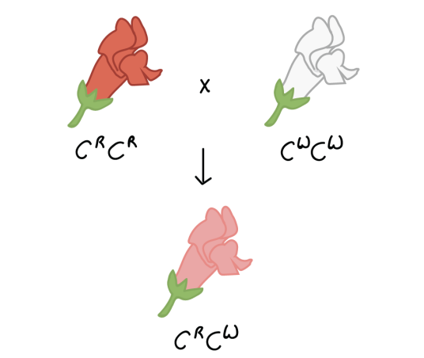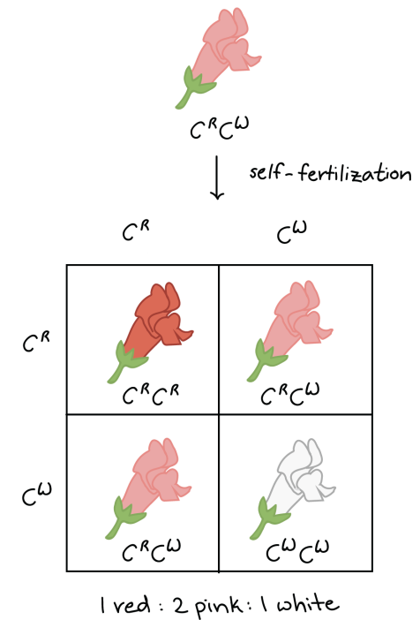

- Codominance and multiple alleles: Co-dominance is the type of dominance where the F1 generation show both of the parental allelic characters and it is not blending of alleles. Both alleles of parental characters may be simultaneously expressed when both are present, rather than one fully determining the phenotype.
When the F1 generation exhibits both the parental characters, this is called codominance. The offspring will be a combination of both the parent. The ABO blood group system is one of the best examples of codominance.
There are different types of red blood cells such as A, B, AB and O with or without the Rh factor. The difference is in the antigen present on the red blood cell surface which determines the specific blood group in an organism.
For example: If a person is blood group A, it means the RBC surface consists of antigen-A.But this is decided by the gene I. The gene I have three types of alleles namely, IA, IB and i. The alleles IA and IB produce two different antigens while the allele-i do not produce any antigen. Hence, alleles IA and IB are dominant over the allele i.
As we know, each diploid organism bears two pairs of alleles. Hence, in humans, there are two types of alleles of any combination. Depending on the combination and dominance of allele blood type of an individual could be determined. The different combination of alleles and their type of blood groups are given below.

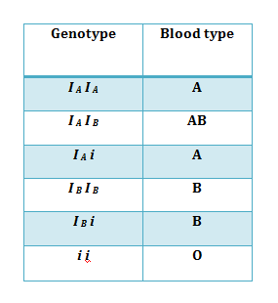
In the above example, A person with blood group A indicates that he has an IA and i pair of alleles. This is because the allele i is recessive in character and no antigen is produced. However, a person who possess both the alleles IA and IB, they have blood group AB. This is because of alleles IA and IB are codominant. Both the gene will produce their type of antigen.
- Multiple alleles: When more than two alternative forms of a gene (alleles) can occupy the same locus. Thus, three or more kinds of genes occupying the same locus in individual chromosome are referred to as multiple alleles. In short many alleles of a single gene are called multiple alleles. The concept of multiple alleles is described under the term “multiple allelism” However, only two of the alleles can be present in a single organism.
Multiple alleles are situated on homologous chromosomes at the same locus. There is no crossing over between the members of multiple alleles. Crossing over takes place between two different genes only (inter-generic recombination) and does not occur within a gene (intragenic recombination).
Alleles are alternative forms of a gene, and they are responsible for differences in phenotypic expression of a given trait (e.g., brown eyes versus green eyes). A gene for which at least two alleles exist is said to be polymorphic. Instances in which a particular gene may exist in three or more allelic forms are known as multiple allele conditions. It is important to note that while multiple alleles occur and are maintained within a population, any individual possesses only two such alleles (at equivalent loci on homologous chromosomes).

Examples Of Multiple Alleles
The ABO system of blood groups is controlled by three alleles, only two of which are present in an individual.
The ABO system in humans is controlled by three alleles, usually referred to as I^{A}, I^{B}, and I^{O} (the "I" stands for isohaemagglutinin). I^{A} and I^{B} are codominant and produce type A and type B antigens, respectively, which migrate to the surface of red blood cells, while I^{O} is the recessive allele and produces no antigen. The blood groups arising from the different possible genotypes are summarized in the following table.
Genotype | Blood Group
I^{A} I^{A} | A
I^{A} I^{O} | A
I^{B} I^{B} | B
I^{B} I^{O} | B
I^{A} I^{B} | AB
I^{O} I^{O} | O

- In Mendelian inheritance, in case of pea a given locus of chromosome was occupied by 2 kinds of genes, i.e., a normal gene (for round seed shape) and other its mutant recessive gene (wrinkled seed shape). But it may be possible that normal gene may show still many mutations in pea besides the one for wrinkledness. Here the locus will be occupied by normal allele and its two or more mutant genes. Multiple alleles influence one or the same character only.
- Wings of Drosophila: In Drosophila wings are normally long. There occurred two mutations at the same locus in different flies, one causing vestigial (reduced) wings and other mutation causing antlered (less developed) wings. Both vestigial and antlered are alleles of the same normal gene and also of each other and are recessive to the normal gene.
there are three races of Drosophila:
(i) Long ++ (+/+) dominant allele
(ii) Vestigial vg vg (vg/vg) recessive allele
(iii) Antlered vgª vgª (vgª/vgª) recessive allele

Pleiotropy. In genetics, Pleiotropy is defined as the expression of multiple traits by a single gene. Pleiotropy is derived from a Greek word meaning more ways. Pleitropic gene affect many different characteristics, not just a single characteristic.
A simple example of a Pleiotropy is phenylketonuria disease. It is a genetic disorder caused by the defective metabolism of the amino acid phenylalanine in the body cells. Phenylketonuria causes this amino acid to increase in amount in the body, which can be very dangerous. The disease is caused by a defect in a single gene on chromosome 12 that codes for enzyme phenylalanine hydroxylase (which converts the amino acid phenylalanine to tyrosine. The genes with this ability are called pleiotropic genes and the phenomenon is known as pleiotropism.
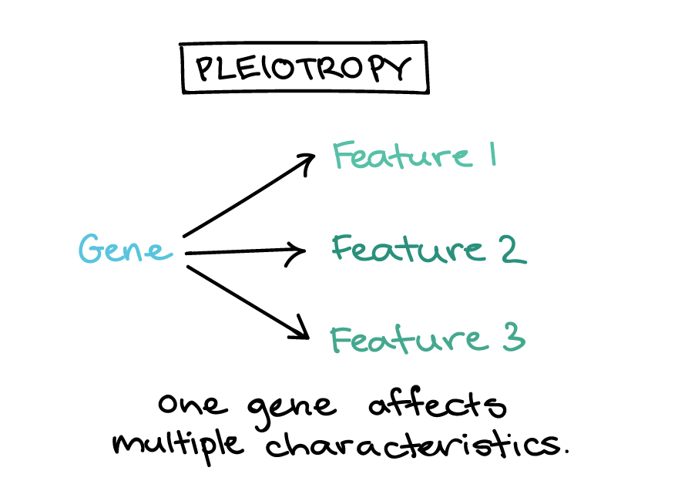
the gene that causes phenylketonuria is pleiotropic and produces many abnormal phenotypic traits such as short stature, mental retardation, pigmentation in the skin, excessive sweating etc.
Sickle cell anemia is a genetic disease that causes deformed red blood cells with a rigid, crescent shape instead of the normal flexible, round shape.[31] It is caused by a change in one nucleotide, a point mutation[32] in the HBB gene. The HBB gene encodes information to make the beta-globin subunit of hemoglobin, which is the protein red blood cells use to carry oxygen throughout the body. Sickle cell anemia occurs when the HBB gene mutation causes both beta-globin subunits of hemoglobin to change into hemoglobin S (HbS).[33]

Sickle cell anemia: Another example of pleiotropism in man is seen in the condition of sickle cell anaemia. Sickle cell anaemia is characterised by sickle shaped red blood cells and anaemia. Sickle cell anemia is a pleiotropic disease because the expression of a single mutated HBB gene produces numerous consequences throughout the body. The mutated hemoglobin forms polymers and clumps together causing the deoxygenated sickle red blood cells to assume the disfigured sickle shape [34] As a result, the cells are inflexible and cannot easily flow through blood vessels, increasing the risk of blood clots and possibly depriving vital organs of oxygen. Some complications associated with sickle cell anemia include pain, damaged organs, strokes, high blood pressure, and loss of vision. Sickle red blood cells also have a shortened lifespan and die prematurely.
A human genetic disorder called Marfan syndrome is caused by a mutation in one gene, yet it affects many aspects of growth and development, including height, vision, and heart function. This is an example of pleiotropy, or one gene affecting multiple characteristics.
Lethal alleles. Lethal alleles are alleles that cause an organism to die only when present in a homozygous condition. The gene involved is considered an essential gene and the lethal allele may be either dominant or recessive
An example of lethal alleles in humans is achondroplasia, a genetic condition which causes dwarfism. The lethal allele is dominant and hence causes the death of the organism when present he homozygous dominant state (AA). If present heterozygous condition (Aa), it will possess a significantly shorter stature (dwarfism), while homozygous recessive (aa) individuals will be normal size.
By causing the death of one genotypic variant, lethal alleles create altered genotypic and phenotypic ratios to the norm
Normally a cross of two heterozygotes will generate a 3 : 1 ratio (dominant : recessive)
In achondroplasia, two dwarf heterozygotes are expected to generate a 2 : 1 ratio (the homozygous dominant doesn’t survive)
Lethal Alleles – Achondroplasia
AA (lethal) X aa (normal)
F1 generation - Aa dwarfism
F2 generation AA Aa Aa aa
Die 2 dwarf 1 normal

E. Baur (1907) observed lethal gene in Snapdragon (Antirrhinum) and found that it is characterized by variegated leaves. The “golden” variety on selfing gives rise to 2 types of offsprings, golden and green in the ratio of 2:1 instead of 3: 1. The golden ones are heterozygous and the green ones breed true being recessive homozygous.
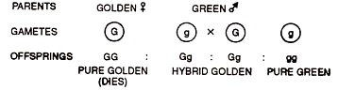

Types of Lethal Genes:
1. Recessive lethals
2. Dominant lethals

