Department of Electronics

L.S. College, Muzaffarpur

TDC -Part1

Triode
In a Triode the electrons are projected out of the cathode by its HEAT energy and without the anode voltage applied, they form an electron cloud which will hover around the cathode as for one negative charged electron that leaves the cathode will become positive relatively speaking. So a positive anode voltage is applied to act as a vacuum cleaner to pull the negatively charged electrons along the transit path to the Anode. Now it is imperative to mention that the Grid is a voltage controlled gate is not a “current” controlled gate as in the transistor,and more like the FET. But let us leave that alone for the time being. It is imperative to mention that once the electrons leave the cathode, they need to travel through an insulator AND THEY MUST NOT TOUCH EACH OTHER but leave a space between them which must be a good insulator or a very good semiconductor.
This space between the individual electrons in the transit path is imperative so that the output resistance of the Triode as seen from the Anode is very high indeed and it is this characteristic that makes the triode a Current amplifier. The electrons on their path to the anode are like bullets in a machine gun, they must not touch each other and they must travel through a vacuum or an insulator with a compromise on a semiconductor in transistor and FET devices. If the electrons had to touch one another they will form a short circuit as happens in an arc in a welding set or their travel through copper.
This state of affair makes the triode a current generator with High or infinite output impedance, which is imperative to hold the current constant at the output, irrespective of the load at the anode. This is not the case in a voltage generator which has a Low or zero output impedance so that the voltage output will not change when any loaded is connected. I say that the electrons in a voltage generator must touch each other to ensure a low output impedance and a constant output voltage. Of course nothing is ideal , but in the old days more than 70 years ago this is what I told my students as this is something they would not find in books nor freely understand as to why there were the differences in the manner the currents flow in practical current and voltage sources where coming from.
Now when it comes to the grid meshed gated element inside the triode, it is the electric field that controls the passage of the electric charge on the electron, which are like horses with an electric charge. The gate or the grid is given a Negative potential to hold the electron back at the cathode . Then slowly the grid VOLTAGE is made less negative or is increased slowly till numerous electrons get through because the Positive anode Voltage is acting like a powerful vacuum cleaner pulling them up while the Negative voltage on the grid is trying to hold them back. Well at quiescent condition a constant number of electrons get through the meshed grid or gate and they proceed to the Anode without touching each other, keeping their distance till they arrive at the Anode.
The Anode terminal must be regarded as a constant current source and the value of this current depends solely on the value of the VOLTAGE at the grid. If the grid is supplied from a Voltage source there is no need to use series resistors as some people think, but if the grid is supplied from a current source then one must use a resistor to change the current into a voltage. This arrangement can be called the bias voltage required to pass the quiescent current to the anode. Later one shall add a signal to all this grid voltage to modulate the flow of electrons to the anode.
Now at the Anode, what ever is connected , for a given grid voltage the number of electrons will not change, one can short circuit the anode to the supply voltage, use a resistor or an inductor or a capacitor, only the same number of anode electrons/current will pass through. With a capacitor one needs to be careful as it will only be a transient action. One uses a resistor to change the current supplied by the anode into a voltage , where this arrangement will result in the output voltage being out of phase with the voltage at the grid. The coupling to the next stage is normally done with an isolating capacitor, but we shall not go into that.
Sometimes here is also a grid leak resistor used with a capacitor across it, but I shall not go into that. This grid leak resistor will act as a change of bias to the triode just in case the grid takes some of the current that were on their way to the anode as happens in oscillating circuits, but again we shall not go into that and stay on amplifiers.

This refinement was necessary in order to avoid some undesired effects of an incandescent filament as an electron emitter.
First, a filament experiences a voltage drop along its length, as current overcomes the resistance of the filament material and dissipates heat energy. This meant that the voltage potential between different points along the length of the filament wire and other elements in the tube would not be constant.
For this and similar reasons, alternating current used as a power source for heating the filament wire would tend to introduce unwanted AC “noise” in the rest of the tube circuit.
Furthermore, the surface area of a thin filament was limited at best, and limited surface area on the electron emitting element tends to place a corresponding limit on the tube\’s current-carrying capacity.
The cathode was a thin metal cylinder fitting snugly over the twisted wire of the filament. The cathode cylinder would be heated by the filament wire enough to freely emit electrons, without the undesirable side effects of actually carrying the heating current as the filament wire had to.

Triode Symbol
The tube symbol for a triode with an indirectly-heated cathode looks like this:
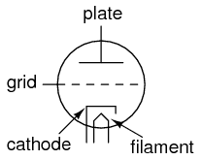
Since the filament is necessary for all but a few types of vacuum tubes, it is often omitted in the symbol for simplicity, or it may be included in the drawing but with no power connections drawn to it:
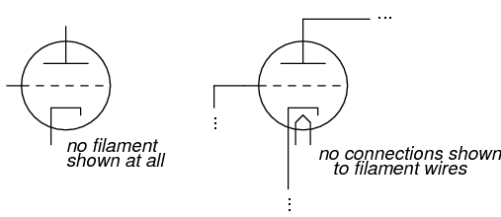

Triode Amplifier Circuit
A simple triode circuit is shown to illustrate its basic operation as an amplifier:
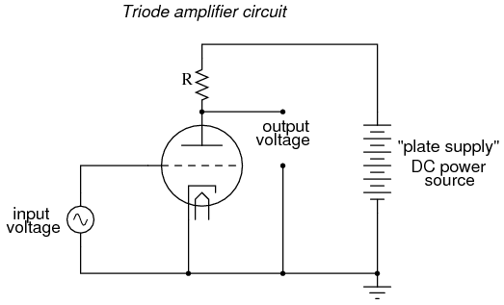
The low-voltage AC signal connected between the grid and cathode alternately suppresses, then enhances the electron flow between cathode and plate. This causes a change in voltage on the output of the circuit (between plate and cathode).
The AC voltage and current magnitudes on the tube\’s grid are generally quite small compared with the variation of voltage and current in the plate circuit.
Thus, the triode functions as an amplifier of the incoming AC signal (taking high-voltage, high-current DC power supplied from the large DC source on the right and “throttling” it by means of the tube\’s controlled conductivity).
In the triode, the amount of current from cathode to plate (the “controlled” current is a function both of grid-to-cathode voltage (the controlling signal) and the plate-to-cathode voltage (the electromotive force available to push electrons through the vacuum).
Unfortunately, neither of these independent variables have a purely linear effect on the amount of current through the device (often referred to simply as the “plate current”). That is, triode current does not necessarily respond in a direct, proportional manner to the voltages applied.
In this particular amplifier circuit the nonlinearities are compounded, as plate voltage (with respect to cathode) changes along with the grid voltage (also with respect to cathode) as plate current is throttled by the tube. The result will be an output voltage waveform that doesn\’t precisely resemble the waveform of the input voltage.
In other words, the quirkiness of the triode tube and the dynamics of this particular circuit will distort the waveshape. If we really wanted to get complex about how we stated this, we could say that the tube introduces harmonics by failing to exactly reproduce the input waveform.

Stray Capacitance
Another problem with triode behavior is that of stray capacitance. Remember that any time we have two conductive surfaces separated by an insulating medium, a capacitor will be formed.
Any voltage between those two conductive surfaces will generate an electric field within that insulating region, potentially storing energy and introducing reactance into a circuit.
Such is the case with the triode, most problematically between the grid and the plate. It is as if there were tiny capacitors connected between the pairs of elements in the tube:
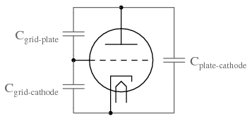
Now, this stray capacitance is quite small, and the reactive impedances usually high. Usually, that is, unless radio frequencies are being dealt with.

Triode Valve / Tube Formulas & Theory

The amplification factor, anode or plate resistance; and the transconductance are some of the key factors associated with the triode valve / tube theory and formulas.

When designing, repairing, or servicing triode valve / triode vacuum tube circuits it is very useful to have an understanding of the theory and what the different performance specifications mean.
The voltage and current relations in the triode for both anode and grid are of importance along with figures like triode amplification factor, the anode or plate resistance and the transconductance.
All of these give an understanding of the performance of a particular triode vale or triode vacuum tube.

Triode voltage & current relations
The number of electrons that reach the anode of a triode valve or vacuum tube under space charge limited conditions is primarily governed by the electrostatic field in the cathode grid region.
Once the electrons have passed through the grid they travel on towards the anode very rapidly and space charge effects can normally be ignored, especially to a first approximation which is normally good enough for most calculations.
The critical area of the triode valve is within the cathode grid space. It is here that the theory needs to be examined to determine its operation.
In the cathode – grid area the electrostatic field is determined by both the grid and anode or plate.
Electrostatic shielding theory shows that the electrostatic field in the vicinity of the cathode of a triode is proportional to (E_{c} + E_{b}/µ), where E_{c} and E_{b} are the grid and anode voltages respectively. The voltages are measured with respect to the cathode. µ is the amplification factor of the valve.

Triode amplification factor µ
The value µ is the constant known as the amplification factor of the valve or vacuum tube – it applies to triodes and is not really applicable to tetrodes or pentodes. It is independent of the voltages on the grid and anode and is determined by the geometries of the elements within the valve. Typically of the grid is placed close to the cathode this will give it a high amplification factor. For most triodes the amplification factor falls within the region of 10 to 100.
The amplification factor µ of a triode valve / vacuum tube is a measure of the relative effectiveness of the grid and anode voltages in producing the electrostatic fields at the surface of the cathode.
In more practical terms the amplification factor, µ of a triode can be considered to be the theoretical maximum gain that can be obtained. The amplification factor is based on the variation of anode voltage to grid voltage, but it is measured with the anode current held constant.
µ=ΔVa/ΔVg
Where:
µ = amplification factor
ΔVa = change in anode voltage
ΔVg = change in grid voltage
<="" p="">

Triode characteristic curves
The performance and characteristics of triode valves or vacuum tubes are often represented by a number of graphs detailing their performance.
The characteristic curves or graphs are normally plotted for the relationship of the grid voltage and anode or plate current, and for the relationship of the anode or plate voltage and the corresponding current.
Typical triode grid voltage and anode current characteristic (Eb = anode voltage)
The various curves of grid voltage against anode current all have approximately the same shape, differing mainly in the displacement from each other. This results from the fact that the anode current is determined by the equation (E_{c} + E_{b}/µ).
Typical relationship between anode current and anode current for a triode valve / tube (Ec= grid voltage)
In a similar way that the curves for the grid voltage and anode current are similar, so too are those for anode voltage and current, although it can be seen that the curves for positive grid voltage are rather different.

Anode resistance
The anode resistance or plate resistance is more exactly described as the dynamic anode or plate resistance. It represents the resistance that the anode circuit offers to a small change in voltage.
Therefore when a small increment in anode voltage ΔE_{b} produces a small change in anode current ΔI_{b} the anode resistance can be calculated as follows:
rp=ΔEb/ΔIb=δEb/δIb
Where:
rp = dynamic anode resistance

Triode mutual conductance or transconductance
The transconductance or mutual conductance g_{m} of a triode is defined as the rate of change of anode current with respect to the grid voltage.
It is possible to express this as a simple equation:
ΔIb=ΔEc⋅gm
gm=δIb/δEc=µ/rp
Where:
µ = mutual conductance / transconductance
rp; = anode resistance
The transconductance or mutual conductance is a form of conductance, i.e. the inverse of Ohms. As a result the units in which they were quoted where mhos (Ohm spelt backwards). Nowadays the unit of conductance is the Siemens (S), but for valves / tubes the unit mho is still used.
For valves the figures were normally quoted in µmhos, so be aware as this would make gain figures enormous if the µ was missed.
In very much later calculations associated with valves, gain figures started to be given in terms of mA/ V, where the voltage (V) was applied to the grid, and the current (mA) was the change of plate current for a 1V change of grid current.

