BOTANY

COURSE: M.Sc. II Sem. / B.Sc. III Part /IMB II Part BIOCHEMISTRY

RESPIRATION

Respiration is a catabolic process in which foods (Carbohydrate, protein, fat) are chemically burnt /oxidised to produce energy (ATP), carbon dioxide and water. Since, it involves both breakdown of food as well as synthesis of energy (ATP) and other compounds, it is referred to be an amphibolic (both catabolic & anabolic) process. The term respiration was initially used for breathing in animals but was subsequently extended to include the biochemical reactions by which organic substances like carbohydrates, fats and proteins are broken down to release CO₂, water and energy in all the living organisms.
In respiration, the high energy compounds are oxidised which are called as respiratory substrates. The most ready substrate in respiration is glucose (carbohydrate). Fats and proteins are also respiratory substrates but are next to carbohydrates. Glucose occupies the central position in metabolism. It is stored in the form of high molecular weight polymer such as starch in plants and glycogen in animals. Both types of polysaccharides occur in bacteria. These compounds release glucose to meet the energy demand.
Respiration is one of the prime vital processes, universally present in all the living cells. In aerobes, respiration takes place utilising O_{2,} but in anaerobes O₂ is not required. Anaerobic respiration is found in Yeasts and some other microorganisms. The energy produced in the aerobic respiration is more than that of anaerobic one.
The biochemical reactions of respiration can be written as:

Aerobic-- C₆H₁₂O₆ + 6 O₂ = 6 CO₂ + 6 H₂O + energy (673 K cal.)

Anaerobic-- C₆H₁₂O₆ ------- 2 C₂H₅OH + 2 CO₂ + energy (28 K cal.)

Difference between combustion and respiration:

Burning of coal and other fuels (combustion) is also an oxidative process but it differs from respiration. Both the processes involve oxidation/chemical burning. Combustion is non enzymatic and unregulated process such as burning of fuels and firewood. There is no ATP production. The energy is released as heat & light in uncontrolled manner. Contrary to this, respiration is an enzyme mediated and well regulated biochemical process, which is a prime character of living cells. The energy is stored in the form of bio molecule (ATP), which releases energy as per cell requirements.
Whole process of respiration includes following biochemical steps:

Glycolysis – Glycolysis is the first step of glucose breakdown in respiration which does not require oxygen. Glucose is oxidised to pyruvate in this process. It is ten step enzyme mediated process in which one molecule of glucose gives 2 molecules of pyruvate molecules, with the net gain of 2ATP and 2molecules of reduced Co-factor (NADH) at the end of the process. It takes place in the cytosol and is found both in aerobic and anaerobic organisms. Though, it is energy producing process, initially it consumes two ATP molecules per glucose molecule utilised, but produces four ATP molecules during further reactions.

Krebs’ Cycle/Citric Acid Cycle /Tricarboxylic Acid Cycle -

Pyruvate formed after glycolysis enters into mitochondria. Its entry is catalysed by the enzyme Pyruvate translocase. In mitochondria pyruvate undergoes oxidative decarboxylation and produces an important intermediate compound Acetyl-CoA. Acetyl-CoA follows a cyclic path to generate reduced cofactors such as NADH+ H⁺, FADH₂ , GTP/ATP and CO_{2.} This cycle is referred to as Krebs’ cycle. This cycle is the major source of formation of ATP generating compounds (NADH, FADH₂ & GTP) in aerobic respiration. In this cycle, acetyl- CoA obtained after oxidative decarboxylation of pyruvate combines with oxaloacetate to produce many organic acids and other compounds of metabolic interest.

3. Electron Transport System - This is a sequential chain of redox reactions operating in the mitochondrial inner membrane. This process involves oxidation of reduced Cofactors NADH & FADH₂ (electron & proton donor) by protein complexes arranged in sequence with increasing order of their Reduction potentials. Electrons flow from reduced cofactors through these protein carriers. This transfer of electrons continues through electron carriers (Cytochromes) arranged in many protein complexes which finally reduces to O ₂ (ultimate electron acceptor). Since, ATP is produced in this process (oxidative phosphorylation) in mitochondria; mitochondria are also called as power house of the cell.

GLYCOLYSIS/ Embden Meyerhof Parnas (EMP) pathway

Gr. glykys: sweet, sugar; lysis: breakdown

This pathway is a series of reactions of breakdown of glucose in respiration without involvement of oxygen.This is common to both in aerobic and anaerobic respiration. It is named as EMP pathway after its discoverer G.Embden, O.Meyerhof & J K Parnas. This includes total ten steps of biochemical reactions catalysed by different enzymes. Step 1, 3 and step 10 reactions are irreversible, rest are reversible. This is due to thermodynamic infeasibility in the above mentioned three steps. Enzymes catalysing glycolysis, are present in the cytosol, hence the site for glycolysis is cytosol.
Breakdown of glucose through glycolysis can be written as:

Glucose + 2 NAD⁺ + 2 ADP + 2Pi 2 Pyruvate + 2 NADH + 2 ATP + 2H₂O + 4H⁺

This takes place in the following steps:-

A. Preparatory phase (ATP consuming phase)

1. In the first step of reaction glucose is phosphorylated by ATP catalysed by the enzyme Hexokinase in presence of Mg ⁺⁺.

Glucose +ATP----hexokinase, Mg ⁺⁺---------------------Glucose 6- phosphate +ADP

2 . Glucose 6 phosphate is converted to Fructose 6 phosphate by the enzyme Phosphohoglucoisomerase (PGI)

Glucose 6-p -==PGI======== Fructose 6-p

3 . Fructose 6-p is phosphorylated by another ATP producing Fr. 1, 6- bi phosphate, catalysed by the enz. Phosphofructokinase (PFK) in presence of Mg ⁺⁺.

Fr.6-P + ATP ------------PFK-- Mg ⁺⁺------- Fr.1, 6-BP + ADP

4. FR.1,6- BP is splitted to one molecule each of glyceraldehyde 3-Phosphate (Gly3P) and dihydroxyacetone phosphate (DHAP) catalysed by the enz . aldolase.

FR.1, 6- BP -====-aldolase=====- Gly 3-P + DHAP

5. Gly 3-P & DHAP are inter-convertible to each other catalysed by the enz.Triose phosphate isomerase (TPI).The reaction is reversible and only Gly 3P is used in further conversion. DHAP readily converts to Gly-3P to continue further reactions.

Gly 3-P-===== TPI ===== DHAP

B. Pay-off phase (ATP generating phase)

6. Each Gly 3-P is acted upon by Gly 3-P dehydrogenase along with addition of inorganic phosphate (Pi) to produce 1, 3-biphosphoglycerate.This reaction is a combination of two reactions (a) oxidation of glyceraldehydes to glycerate, by NAD⁺ (b) joining of an orthophosphate with the carboxylic group to form acyl-phosphate.Two molecules of Gly3-P proceed to get oxidised. It is to be noted that, of the two molecules of Gly3-P, one molecule comes from the reversal of DHAP.

2 Gly3-P+2NAD⁺ + p_{i} ===-Gly3P dehydrogenase===2 1,3-Biphosphoglycerate+NADH+H⁺

7.Two molecules of 1,3-BPG are converted to two mol. of 3-Phoshoglycerate (3-PG)by the enz.3P-glyceric kinase (PGK)in presence of Mg ⁺⁺

2 1,3-BPG +2ADP ------PGK—Mg⁺⁺-------2 3-PG + 2ATP

8. Two molecules of 3-PGlycerate are converted to two mol. of 2-PGlycerate(2-PG) by the enz. Phosphoglycerate mutase (PGM)

2 3-PG =======-PGM========-2 2-PG.

9. Two molecules of 2- PG are dehydrated to two mol. of Phosphoenolpyruvate (PEP) by the enz. enolase

2 2-PGly =====-enolase- Mg ⁺⁺====-2 Phsphoenolpyruvate + 2H₂O

10. Two mol. of PEP are acted upon by enz. Pyruvate kinase (PK) in presence of Mg⁺⁺ to produce 2 molecules each of ATP and Pyruvate

2 PEP + 2 ADP ----------PK-, Mg++, K ⁺----- 2 Pyruvate + 2 ATP

This should be noted that 2 Pyruvate molecules are produced from each glucose molecule oxidised. Splitting of Fructose 1, 6-biP gives one molecule each of Gly 3-P & DHAP (STEP4). DHAP is also converted to Gly-3P (step 5) .

The overall balance sheet of energy in glycolysis shows a net gain of 2 ATP

ATP consumed- per unit glucose molecule utilised ------------ 2

ATP produced ------------------- 2X2=4 molecules (step 7 & 10)

Net gain of ATP per glucose mol. utilised ---- 2

------------------------------------------------------------------------------------------------------------------------
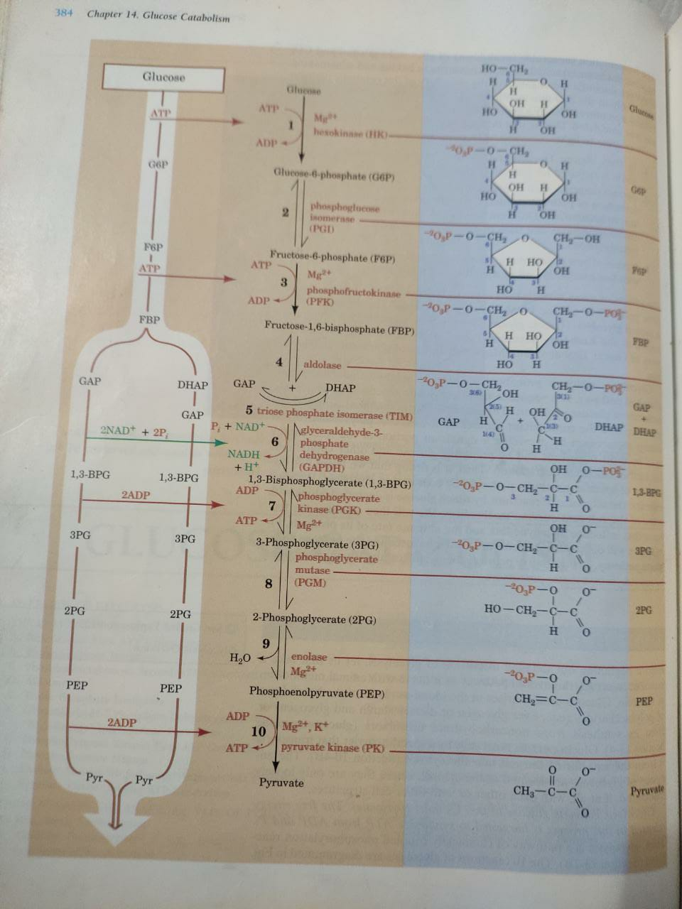
Fig. Glycolysis (courtesy: Fundamentals of Biochemistry,Voet,Voet&Pratt)
______________________________________________________ _____

Fate of Pyruvate after glycolysis—

In eukaryotic aerobic respiration, pyruvate enters into mitochondria and undergoes oxidative decarboxylation mediated by an enz. Pyruvate dehydrogenase (PD).It is a multienzyme complex having combination of three different enzymes namely ( PD ; E₁) , Dihydrolipoyl transacetylase(E₂ ; DLT) & Dihydrolipoyl dehydrogenase (E₃ ; DLD) resulting to decarboxylation & dehydrogenation of Pyruvate. This enzyme is located in the mitochondrial matrix. In prokaryotes such as bacteria, mitochondria are absent and PD is located in the cytosol .
Oxidative decarboxylation of pyruvate requires five Co- factors--Thiamine pyrophosphate (TPP), Lipoamide (LA), acetyl-CoA, FAD & NAD⁺. Following are different steps of reaction:-

Pyruvate +TPP—E₁--------PD----Hydroxyethylthiamine pyrophosphate(HETPP) + CO₂

HETPP + LA (ox)—E₂ ₋₋ DLT----Acetyl- dihydrolipoamide + TPP

Acetyl-dihydrolipoamide + CoA-----E₂--Acetyl-CoA + LA (red.)

LA (red.)+ FAD--------E₃---------- LA (ox.) +FADH₂

FADH₂ + NAD⁺----------E₃--------- FAD + NADH+H⁺

Since, two molecules of pyruvate are produced from one molecule of glucose, the
overall reaction of oxidative decarboxylation of pyruvate can be summed up as :

2 Pyruvate+2CoA+2NAD ⁺-------(PD)------- 2acetyl- CoA +2CO ₂+2NADH+2H⁺

(CoA—Coenzyme A)

In anaerobic respiration, as found in Yeasts , pyruvate is converted to ethyl alcohol & CO₂. However, Yeasts are facultative anaerobes and respire aerobically but under anaerobic condition they respire anaerobically.

C ₃H ₄O₃ (Pyruvic acid) -------------Pyruvic decarboxylase-- CH ₃CHO (Acetaldehyde)+CO ₂

CH₃CHO + NADH+H ⁺----------- Alcohol dehydrogenase---- C ₂H ₅OH (ethyl alcohol)+ NAD ⁺

This reaction is used in production of ethyl alcohol by yeasts .The process is called as alcoholic fermentation and has industrial importance. This is used in alcohol producing industries using yeasts to ferment with suga. CO₂ produced in the reaction leavens bread which is important for bakeries. Another product of anaerobic respiration is Lactic acid, which is produced by Lactobacilli.

Lactic acid bacteria (Lactobacilli) convert Pyruvate to Lactate by the following reaction (Lactic acid fermentation) :

C₃H₄O₃ + NADH+ H⁺ ---------Lactate dehydrogenase------ C₃H₆O₃ + NAD⁺
Pyruvic acid ------------------ Lactic acid

Unlike yeasts, mammals do not have Pyruvate decarboxylase and therefore can not produce ethanol from pyruvate. Instead, pyruvate is reduced to lactate in a reversible reaction catalysed by Lactate dehydrogenase (reaction as above).Lactate is also produced in skeletal muscles under rigorous exercise. It is transported to the liver via bloodstream where it is converted to pyruvate by Lactate dehydrogenase. Further metabolism of pyruvate requires oxygen. Under the condition of inadequate supply of oxygen, lactic acid gets accumulated. Lactic acid causes the muscles to ache during and after exercise.

KREBS’ cycle/Citric acid cycle

Acetyl-CoA formed from pyruvate , is further oxidised by a cycle, known as Krebs’ cycle or Citric acid cycle. This cycle takes place in the mitochondrial matrix which is an ingenious series of eight reactions that oxidises acetyl-CoA to produce two molecules of CO₂ and conserves the liberated free energy in the reduced compounds NADH & FADH₂. In aerobic respiration, this cycle is the main source of formation of NADH and FADH₂ from acetyl -CoA and oxaloacetate. The reduced cofactors NADH & FADH₂ produce ATP in the subsequent step of electron transport system.
Many organic acids having three - COOH groups, are produced as intermediate compounds in the cycle,hence this is called as Tricarboxylic acid cycle. The first intermediate compound formed in the cycle by the condensation of acetyl-CoA and oxaloacetate is Citric acid, hence it is also known as Citric acid cycle. The reactions of Citric acid cycle can be written as:

Acetyl-CoA + 3 NAD⁺+ FAD + GDP + Pi + 2H₂O--- CoA+2CO₂+3NADH+FADH₂ + GTP + 3H⁺

Following are different steps of the cycle :

1. Synthesis of citrate from acetyl- CoA and oxaloacetate catalysed by enz.citrate synthase.

Oxaloacetate + Acetyl -CoA +H₂O ---------(CS)-------- Citrate + CoA

2 Citrate is isomerised to Isocitrate by the enz. aconitase

Citrate ====aconitase=======Cis-Aconitate+H₂O aconitase==Isocitrate+H₂O

3 Isocitrate undergoes oxidative decarboxylation by the enz. Isocitrate dehydrogenase to produce α- Ketoglutarate . An intermediate compound Oxalosuccinate is produced after isocitrate oxidation by NAD⁺ which in turn decarboxylated to produce α- ketoglutarate.

Isocitrate + NAD⁺---------- Oxalosuccinate+ NADH + H⁺-- CO₂ + α- ketoglutarate

4 Enz.α- ketoglutarate dehydrogenase catalyses the oxidative decarboxylation of α- Ketoglutarate to produce Succinyl- CoA , NADH & CO₂

α- Ketoglutarate +NAD⁺ + CoA –(α- Ketoglutarate dehydrogenase)-Succinyl- CoA + CO₂+ NADH+H⁺

5 The next reaction is catalysed by the enz. Succinate thiokinase which generates one GTP equivalent to high energy compound ATP and Succinate.

Succinyl -CoA + Pi===== Succinyl phosphate + CoA

Succinyl phosphate + GDP ======Succinate + GTP
6 Succinate is acted upon by the enz. Succinate dehydrogenase (SD) which converts it to Fumarate

Succinate +FAD ===== (SD)==== Fumarate+FADH₂

7 Fumarate is hydrated by the enz. Fumarase to produce Malate

Fumarate +H₂O ======Fumarase===== Malate

8 Malate is oxidised (dehydrogenated ) by the enz. Malate dehydrogenase (MD) to produce Oxaloacetate, the last reaction of this cycle. It’s cycle because the reaction ends where from it begins (Oxaloacetate)

Malate + NAD⁺=======MD===== Oxaloacetate + NADH+ H⁺

Energy balance sheet:
Reaction step Reduced Co-factors ATP molecules
produced
Steps -1- Pyruvate -----acetyl- CoA----- 2 molecules NADH₂ 2x3=6
Citric acid cycle energy output:-
2-Isocitrate------oxalosuccinate— 2 mol. NADH₂ 2x3=6
3.α- Ketoglutarate----Succinyl -CoA---2 mol. NADH₂ 2x3=6
4-Succinate------------Fumarate ---- 2mol. FADH₂ 2x2=4
5-Malate------------ Oxaloacetate-----2mol.-NADH₂ 2x3=6
GTP produced-- Succinyl-CoA----Succinate-- 1 ATP 2x1=2

Note: 1 NADH₂ produces 3 ATP while 1 FADH₂ produces 2 ATP mol. during oxidative phosphorylation (electron transport system).

ATP molecules produced in aerobic respiration from 1 glucose mol :-

Glycolysis--------------------------8
Pyruvate-- acetyl- CoA ------- -6
Krebs’ cycle-------------------- -24
Total------------------------------38
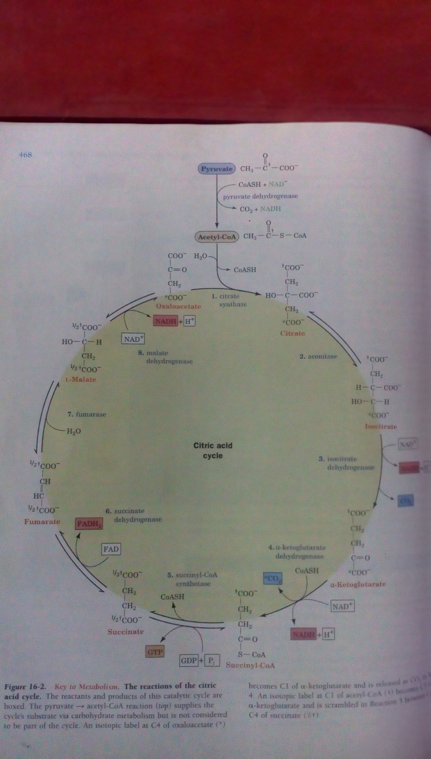

Citric acid cycle .(Fig. Courtesy ; Fundamentals of Biochemistry,Voet,Voet &Pratt.)

Significance of Krebs’ cycle: Krebs’ cycle bears multiple importance in the cellular metabolism. It holds central position in the metabolism. In respiration. it produces most of the energy from glucose molecule. Out of 38 molecules of ATP produced from one mol.of glucose, 24 ATP molecules are contributed from this cycle. Besides this, many other compounds required for the synthesis of amino acids , are intermediates of Krebs’ cycle. Amino acids are used in the synthesis of nucleic acids, proteins. Many organic acids formed in this cycle are precursors of many amino acids such as :

α ketoglutarate --- glutamate

oxaloacetate------- aspartate

many amino acids are derived from these preformed amino acids by transamination reactions.
It is directly related to the nitrogen metabolism. α ketoglutarate is the first acceptor molecule of NH_{3,} forming amino acid glutamatic acid. Amino acids are building blocks of proteins; hence citric acid cycle is directly related with the cellular proteins and enzyme system.
Glutamic acid is the first formed amino acid from α ketoglutarate, which is port of entry of nitrogen in the form of NH₃ in the metabolic pool after nitrogen fixation in N₂ fixing plants

Succinyl -CoA formed in the cycle acts as precursor of chlorophyll, cytochromes and phytochromes.

Krebs’ cycle is also intimately related with the synthesis of anthocyanin and phenols. Acetyl-CoA, which enters into Krebs’ cycle, is also important for the synthesis of anthocyanin and phenols.

Mitochondrial Electron Transport System

Respiratory electron transport system is the sequence of events leading to the synthesis of ATP in the mitochondria and reduction of oxygen to water. It is universally found in all the aerobic organisms. In this process reduced cofactors produced during glycolysis, oxidative decarboxylation of pyruvate and in Krebs’ cycle, donate electrons to electron receiving centres arranged in series in the inner membrane of mitochondria.. Reduced Cofactors (NADH & FADH ₂) are oxidised by the adjacent protein complex (I).Transfer of electrons continues till it reaches to the last receiver O₂, reducing it to H₂O. Electron transfer from NADH and FADH₂ to O₂ takes place through a series of electron (e) carriers arranged sequentially in the increasing order of their reduction potentials (E^{0’}) along the inner membrane of mitochondria. These electron carriers include five protein complexes . These contain flavin mononucleotide (FMN-complex I), Flavin adenine dinucleotide (FAD-complex II), Ubiquinone/ CoQ and cytochromes (complex III & IV). Transport of electrons is accompanied with proton (H⁺) transport from matrix to inter membranous space of mitochondria. The reduced coenzyme FMNH₂ and FADH₂ transfer one electron at a time in the subsequent steps in complex III & IV containing cytochromes. Cytochromes are iron containing proteins in which Fe exists in two forms, which continuously gets reduced ( Fe²⁺) and oxidised (Fe³⁺). Different protein complexes are grouped as:

Complex I NADH : CoenzymeQ Oxidoreductase
II Succinate: CoenzymeQ Oxidoreductase
III Coenzyme Q: Cytochrome c Oxidoreductase/ Cytochrome b c_{I} complex
IV Cytochrome c Oxidase
V ATP Synthase / F₁ F _{O} –ATP ase

Transfer of electrons from one complex to another is guided by their respective reduction potentials (E^{0’}). Flow of electrons takes place from complexes having lesser reduction potential (E^{0’}) to those having greater E^{0’} in the increasing direction. NADH produced in previous reactions bears E0’ -0.315 V & O₂ has E^{0’} 0.815, therefore electron transfer takes place from NADH to O₂ through different protein complexes. This is associated with release of energy which depends on the difference of E^{o’} of the two redox groups. Difference of E^{o’} between $NADH$ and O₂ ( E^{0’}_{acceptor}̶ E^{0’}_{donor}) is 1.130 V. The amount of free energy difference is sufficient to produce three ATP molecules which are conserved in the system. Transfer of electrons through the protein complexes in the inner membrane of mitochondria is associated with transfer of H⁺ which gets transferred from mitochondrial matrix to Inter membranous space (IMS). IMS lies between the inner and outer membranes of the mitochondria.
The sequence of electron transport can be understood by the following steps :

Complex I (NADH : CoQ Oxidoreductase)- This is the largest protein among all the complexes involved in ETS which receives 2 electrons (e)from each NADH ,which get transferred to Flavin mononucleotide (FMN) .FMN contains 2 Fe-2S & 4Fe-4S clusters which participate in electron transfer. FMN gets reduced after receiving electrons .The electrons transit to CoQ takes place and as a result FMN gets oxidised while CoQ gets reduced to CoQH ₂. Protons are also translocated from matrix to IMS along with the electrons.

Complex II (Succinate : CoQ Oxidoreductase) –This complex is also called as Succinate dehydrogenase. This complex contains FAD with three Fe-S centres to facilitate transfer of electrons. The sequence of electron transfer from succinate to CoQ involves reduction of FAD to FADH _{2.} This is followed by transfer of electrons to CoQ ,Two- one electron transfer takes place from FADH ₂ to the series of three Fe-S clusters .As a result of which CoQ gets reduced to CoQH_{2.}.In this sequence, Succinate is oxidised to Fumarate.

Complex III –( CoQ : Cytochrome c oxidoreductase ) - This complex consists of a 2 Fe-2S centre, Cytochrome b and Cytochrome c_{1.} Cyt b here exists in two forms Cyt b_{h} & Cyt b _{l .} This complex functions to allow one molecule of CoQH₂, a two electron carrier to reduce two molecules of Cytochrome c , which can accommodate only one electron at a time. Cyt c gets reduced.
CoQH ₂+ Cyt c 1(Fe³⁺) ------ CoQ ⁻ + Cyt c ₁+ (Fe²⁺) +2 H ⁺ cycle 1 ---Cytosolic
CoQH₂+ CoQ⁻ + Cytc₁ (Fe³) +2H ⁺ (mitochondrial)----- CoQ+CoQH₂+Cytc₁ (Fe²⁺) + H⁺---Cycle2 (Cytosolic)
Cytochrome c is a mobile, peripheral membrane protein which shuttles between complex III & IV .It transfers one electron at a time from Cyt c ₁(complex III) to Cu _{A} (complex IV).

Complex IV -( Cytochrome c Oxidase) - This is the last complex associated with ETS. This contains Cytochromes a and a₃ and reduction factors Cu _{A} and Cu _{B .}This receives electrons from Cytochrome c, (a mobile protein ). Electrons flow through Cyt a,a_{3,} Cu _{A} and Cu _{B’} This transfers electrons to O₂ which gets reduced to water. In this transfer of electrons protons are translocated from reduced cofactors to the inter membranous space.

Complex V – ATP synthase/F₁-F₀ ATPase – This complex is a multi subunit protein of 180 A⁰ size which has two major units F₀ (50A⁰) and F₁(50 A⁰).The former F₀ is a water insoluble transmembrane proton channel having eight subunits while the later F₁ is a water soluble peripheral protein consisting of five types of protein subunits. This subunit is the site of ATP generation. The electron micrograph shows that the F₁ faces the matrix but F_{o} is embedded in the inner membrane . F₁and F₀ are connected with a stalk(50 A⁰) .The protein subunits of F₁ undergoes conformational changes. They receive ADP and Pi, bind them and release ATP.

Chemiosmotic theory and Proton motive force :

Chemiosmotic theory was given by Peter Mitchell (1961) to explain the ATP generation mechanism due to the proton motive force(pmf), developed between the inter membranous space and matrix of mitochondria. Since protons/H⁺ are translocated from the matrix to the IMS along with electrons flow ,the concentration of H ⁺ becomes greater than that in matrix, an electrochemical H⁺ concentration gradient develops between the mitochondrial matrix and inter membranous space. There develops a force , called as Proton Motive Force (pmf).The electrochemical potential of this gradient is harnessed to synthesize ATP. (Oxidative Phosphorylation)As a result of accumulation of H⁺ in the IMS , H⁺ tends to move to matrix through the H⁺ transport channel present in the F!-F_{o} ATP ase (complex V). Hence F₁ stalk of the F! – F₀ complex is named as H ⁺ transport channel. This process is responsible to drive the force to generate ATP in the ATP Synthase (complex V).This theory is supported by many experimental evidences and nature of mitochondrial inner membrane.

1. The inner membrane is impermeable to H⁺, OH⁻ , K⁺ , Cl – and their free movement /diffusion would discharge the electrochemical gradient. Oxidation of NADH and FADH₂ is synchronized with ATP production due to H⁺ transport & electrochemical potential gradient.

2. Many compounds (chemical uncouplers) which increase the membrane permeability to protons are also able to dissipate the electrochemical potential developed there. As a result of this, ATP synthesis is inhibited.

Oxidative phosphorylation :
Mitochondria are the site of oxidative phosphorylation was discovered by Kennedy and Lehninger (1948). In eukaryotic aerobic respiration, ATP is generated from ADP and pi as a consequence of electron transport in mitochondria. This is referred to as oxidative phosphorylation. Since, the phosphorylation occurs during oxidation of reduced cofactors NADH & FADH₂ by O_{2,} this is named as oxidative phosphorylation. ATP formation requires energy which is made available by the redox reactions during the electron transport. The energy conservation in the form of ATP is linked with electron transport and is referred to as chemical coupling. During phosphorylation the required amount of energy to bind ADP & Pi, is made available by the free energy produced at following steps:

1. NADH+H⁺-------------NAD⁺ 2. FADH₂-------- 2e⁻------FAD ) (E⁰ -0.36 V/∆G^{0’} -69.5 kJ.mol⁻¹)

ATP

ATP
(E^{0’} 0.190V,∆G^{0’}-36.7kJ/mol.)
CoQ CoQH₂ ₋Cyt bCytc₁Cyt c

ATP

3. Cyt c (red.)—2e-C u _{A} -Cyt aCyt-a₃ –C u _{B}---2e---+ ½ O₂+ 2H⁺---H ₂ O (matrix)
Cyt c (ox) (E^{0’} 0.580 V/∆G^{o’} -112 kJ.mol⁻¹)

FADH₂ also transfers electrons to CoQ parallely, but the free energy (∆G^{0’}) for electron transfer from succinate to CoQ is insufficient to generate ATP synthesis. This is the reason that only two ATP molecules are produced from FADH₂

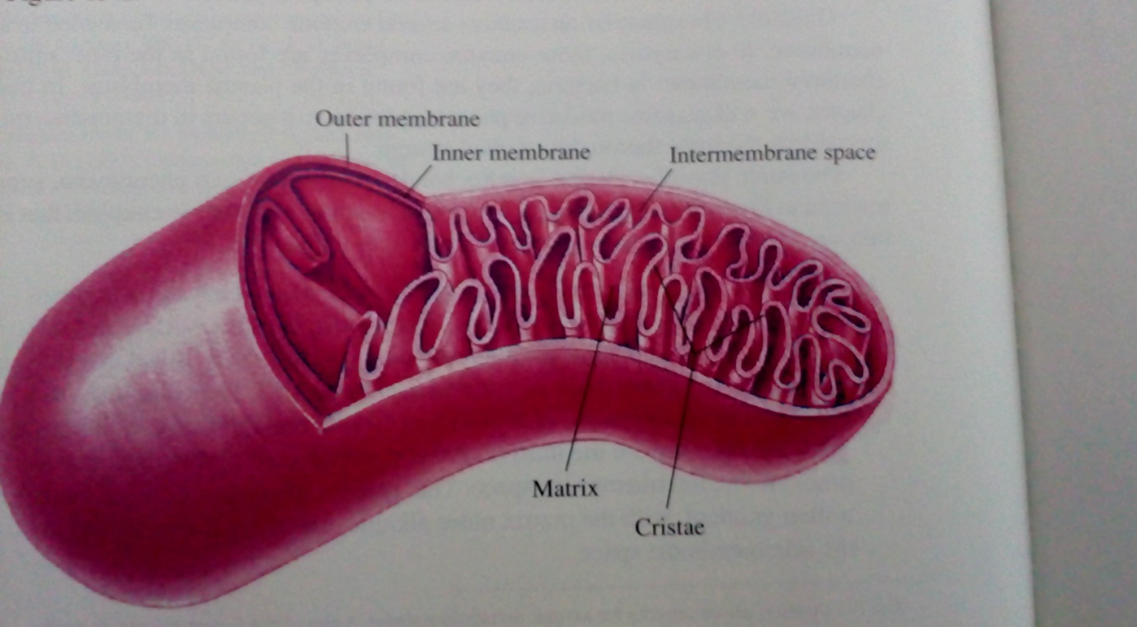

Fig. Showing external and internal structure of mitochondrion. (Courtesy; Principles of Biochemistry, Horton, Moran, Ochs, Rawn & Scrimgeour. Publ. Prentice –Hall IN, Inc.)

Electron transport and Oxidative phosphorylation in Bacteria :

In bacteria, mitochondria are absent, the electron transport system is located in the plasma membrane and the protons are translocted from the cytosol to the outside of plasma membrane. Like mitochondrial system, in aerobic bacteria electrons flow from CoQ through cytochrome based oxidoreductases to O₂ which is reduced to H₂O.

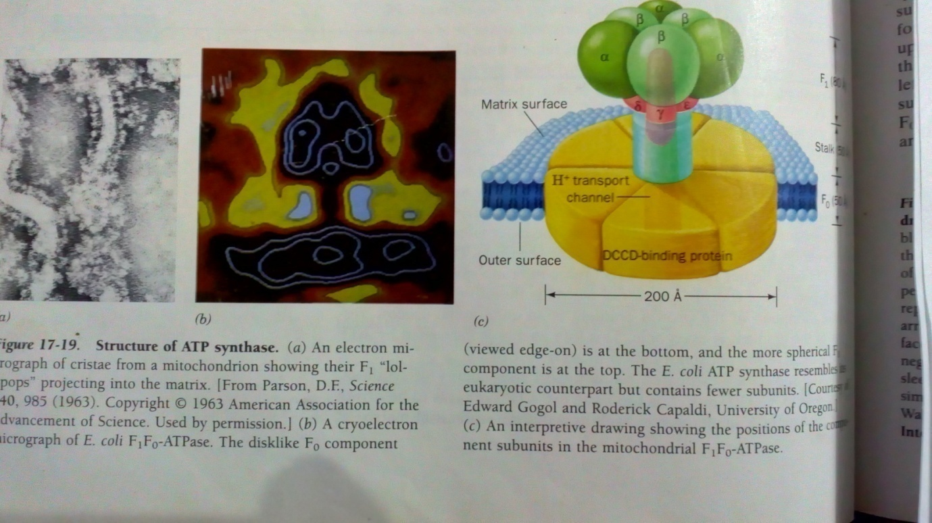

Fig. ATP synthase/ F₁-F₀ ATP ase(Courtesy ; Fundamentals of Biochemistry, Voet, Voet & Pratt.Publ. John Wiley & sons, Inc.)

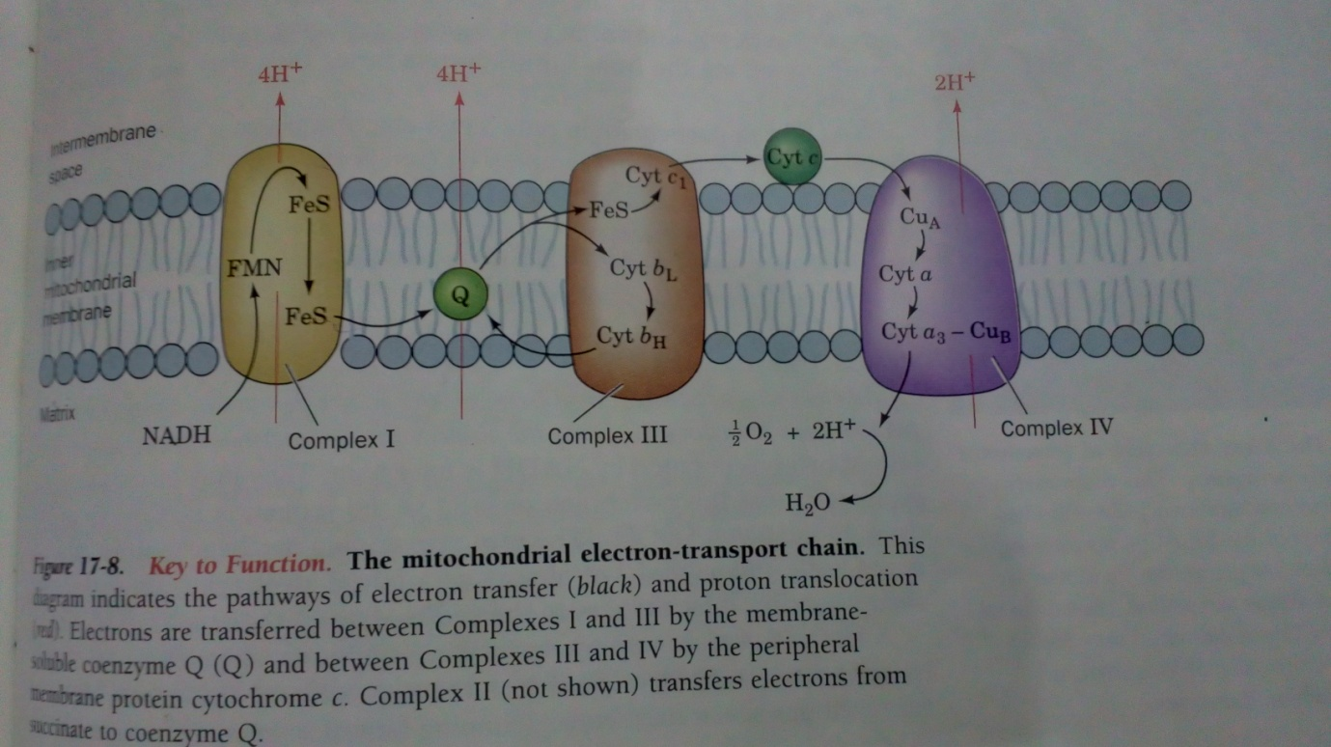

Fig. showing mitochondrial electron transport system.(Courtesy; Fundamentals of Biochemistry, Voet , Voet & Pratt. Publ.John Wiley & sons, Inc.)

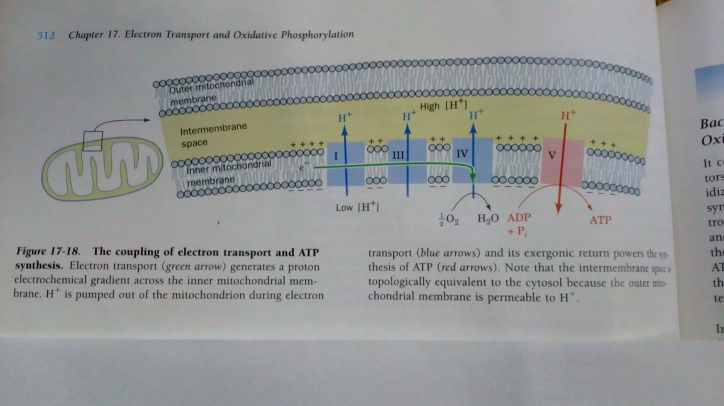

Fig. showing coupling of electron transport with oxidative phosphorylation.(Courtesy; Fundamentals of Biochemistry ,Voet,Voet & Pratt.)

