TDC Part II
Paper I, Group B
Inorganic Chemistry

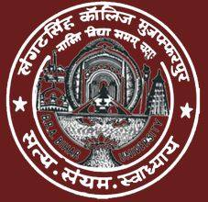

Department of Chemistry

L.S COLLEGE MUZAFFARPUR
B. R. A. BIHAR UNIVERSITY
Dr. Priyanka
TOPIC:-UNIT -3,SUMMARY PRACTICE QUESTIONS

SUMMARY

In this unit, an effort has been made to discuss the general characteristics of the elements of the second transition series such as their electronic configuration and variation in the oxidation states, magnetic behaviour, complex formation tendency, colour of the compounds/complexes, catalytic activity, formation of interstitial and non-stoichiometric compounds, metallic character and alloy formation along with the periodic properties and their variation across the period. A comparative account of these elements with their 3d analogues in respect to their ionic radii, oxidation states and magnatic behaviour has also been given. A brief discussion of spectral properties and a tabular account of the stereochemistry of the compounds of the elements of this series have also been recorded. It is hoped that this will enable the learners to understand the subject matter in a better and easier way.

PRACTICE QUESTIONS

- What are the transition elements? Why are they called so?
- Mention three main factors that enable transition elements to form complexes.
- Write down the names and symbols of 4d and 5d congeners of element manganese.
- Which ion is more stable Ag⁺ or Ag²⁺ and why?
- Write down the valence shell electronic configuration of Pd (Z = 46).
- Write down two applications of Pd as catalyst.

