Dr. Rima Kumari: Date: 07/07/2020
Online class and e- content for B.Sc. Ist year students

Date and Time | Online class medium | E. content topic
07/07/2020  12:30 p.m to 1.20 p.m | Via Google meet  Link: Meeting URL: https://meet.google.com/mnc-ehma-daw | Role of microbes in Biological nitrogen Fixation

Chapter: Role of Microbes in Nitrogen fixation
Nitrogen fixation:
Apart from carbon, hydrogen and oxygen, nitrogen is the most important essential macro-element in living organisms. Plants need nitrogen to build amino acids, proteins, nucleic acids, cytochromes, chlorophylls, alkaloids, phytohormones and many of the vitamins. Plants compete with microbes for limited nitrogen content available in the soil.
Nitrogen occurs in atmosphere as free diatomic (N₂) molecules form. Nearly 80% of Earth atmosphere contains nitrogen in the form of a highly inert di-nitrogen (N = N) which most plants cannot utilize as such, and therefore has to be fixed. Nitrogen-fixing microorganism capable to fixes atmospheric nitrogen into biologically available form (in inorganic compounds usable by plants). This termed as nitrogen fixation.
Means of Nitrogen fixation:
- physicochemical (non-biological) About 10% of natural nitrogen fixation takes place by physicochemical methods
- Biological means. 90% by biological methods.

Physical nitrogen fixation
i) by environmental physical factors lightning (electric discharge in the clouds) and thunder, in these cases N₂ and O2 of the air react to form nitric oxide (NO). The nitric oxides are again oxidized with oxygen to form nitrogen peroxide (NO₂).

(ii) Industrial Nitrogen Fixation:
Ammonia is produced industrially by direct combination of nitrogen with hydrogen (obtained from water) at high temperature and pressure. Later, it is converted into various kinds of fertilizers, such as urea etc.

Biological nitrogen fixation:
More than 90 percent of all nitrogen fixation is affected by micro-organisms, which thus play an important role in the nitrogen cycle. The conversion of atmospheric nitrogen into the nitrogenous compounds through the agency of micro-organisms is called biological nitrogen fixation (BNF). So Biological nitrogen fixation is the phenomenon of reduction of inert gaseous di-nitrogen (N₂) into ammonia (NH₃) through the agency of some microorganisms so that it can be made available to the plants. Biological nitrogen fixation is also called as diazotrophy and micro-organism involved in process of biological nitrogen fixation is called diazotrophs. It occur due to presence of enzyme nitrogenize produced by certain microbes. Nitrogenize is a biological catalyst found naturally only in certain microorganisms such as the symbiotic Rhizobium and Frankia, or the free-living Azospirillum and Azotobacter and blue green algae (BGA) and this enzyme help in process of biological nitrogen fixation

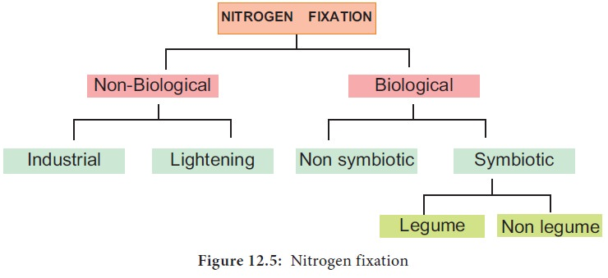

Role of Microbes in Biological nitrogen fixation

Mainly two main types of microorganism involved in biological nitrogen fixation:
- Free-living (non-symbiotic) Nitrogen Fixing bacteria
- Symbiotic Nitrogen Fixing bacteria

Non-symbiotic bacteria:
- Free-living (non-symbiotic) Nitrogen Fixing bacteria Azotobacter, Beijerinckia (bothaerobic) and Clostridium (anaerobic) are saprophytic bacteria that perform nitrogen fixation. Desulphovibrio is chemotrophic nitrogen fixing bacterium. Rhodopseudomonas, Rhodospirillum and Chromatium are nitrogen fixing photoautotrophic bacteria. These bacteria add up to 10-25 kg, of nitrogen/ha/annum.

- Free-living (non-symbiotic) Nitrogen Fixing cyanobacteria Many free living blue-green algae (now called cyanobacteria) perform nitrogen fixation, e.g., Anabaena, Nustoc, Aulosira, Cylmdrospermum, Trichodesmium. These are also important ecologically as they live in water-logged sods where denitrifing bacteria can be active. Aulosira fertilissima is the most active nitrogen fixer in Rice fields, while Cylindrospermum is active in sugarcane and maize fields. They add 20-30 kg Nitrogen/ha/annum.

Symbiotic bacteria:
Symbiotic Nitrogen Fixing bacteria
Rhizobium is aerobic, gram negative nitrogen fixing bacterial symbionts of Leguminaceae roots. Several species of Rhizobium live in the soil but are unable to fix nitrogen by themselves. They do so only as symbionts in the association of roots of legumes. Sesbania rostrata has Rhizobium in root nodules and Aerorhizobium in stem nodules. Frankia is symbiont in root nodules of many non-leguminous plants like Casuarina and Alnus. Xanthomonas and Mycobacterium occur as symbiont in the leaves of some members of the families Rubiaceae and Myrsinaceae (e.g., Ardisia). Frankia, associated with certain dicotyledonous species (actinorhizal plants); and certain Azospirillum species, associated with cereal grasses.
Symbiotic Nitrogen Fixing cyanobacteria
Anabaena and Nostoc species are common symbionts in lichens, Anthoceros, Azolla and cycad roots. Azolla pinnata (a water fern) has Anabaena azollae in its fronds. It is often inoculated to Rice fields for nitrogen fixation.
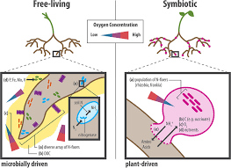

Symbiotic Nitrogen Fixation:
Both Rhizobium sp. and Frankia are free living in soil, but only as symbionts, can fix atmospheric di-nitrogen. The symbiotic nitrogen-fixing bacteria invade the root hairs of host plants, where they multiply and stimulate the formation of root nodules, enlargements of plant cells and bacteria in intimate association. Within the nodules, the bacteria convert free nitrogen to ammonia, which the host plant utilizes for its development. To ensure sufficient nodule formation and optimum growth of legumes (e.g., alfalfa, beans, clovers, peas, and soybeans), seeds are usually inoculated with commercial cultures of appropriate Rhizobium species, especially in soils poor or lacking in the required bacterium.
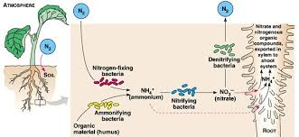

The symbiotic nitrogen fixation can be discussed under following steps:
(i) Nodule formation:
It involves multiple interactions between free-living soil Rizobium and roots of the host plant. The important stages involved in nodule formation are as follows-Host Specificity: A variety of microorganisms exist in the rhizosphere (i.e. immediate vicinity of roots) of host roots.
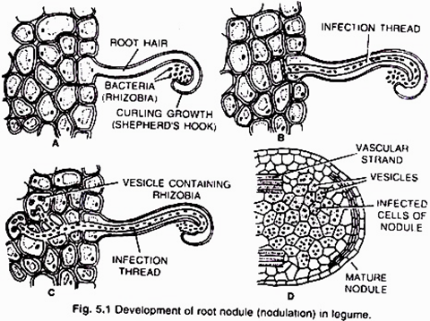
The roots of young leguminous plants secrete a group of chemical attractants like flavonoids and betaines. In response to these chemical attractants specific rhizobial Tells migrate towards the root hairs and produce nod (nodulation) factors. The nod factors found on bacterial surface bind to the lectin proteins present on the surface of root hairs. This lectinnod factor interaction induces growth and curling of root hairs around Rhizobia.
At these regions wall degrades in response to node-factors and Rhizobia enter the root hair invagination of plasma membrane called infection thread. The infection thread filled with dividing Rhizobia elongate through the root hair and later branched to reach different cortical cells.
The Rhizobia are released into the cortical cells either single or in groups enclosed by a membrane. The Rhizobia stop dividing, loose cell wall and become nitrogen fixing cells as led bacteroids .The membrane surrounding the bacteroids is called peribacteroid membrane. The infected cortical cells divide to form nodule (Fig. 5.2).
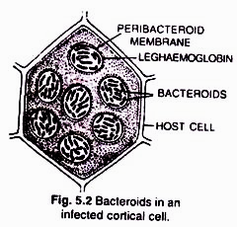

(ii) Mechanism of nitrogen fixation (Fig 5.3):
The nodule serves as site for N₂ fixation. It contains all the necessary bio-chemicals such as the enzyme complex called nitrogenase and leghaemoglobin (leguminous haemoglobin). The nitrogenase has 2 components i.e. Mo-Fe protein (molybdoferredoxin) and Fe-protein (azoferredoxin).The nitrogenase catalyzes the conversion of atmosphere di-nitrogen (N₂) to 2NH₃. The ammonia is the first stable product of nitrogen fixation.
The overall equation is:
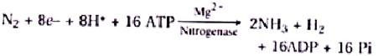

The nitrogenase is extremely sensitive to oxygen. To protect these enzymes, nodule contains an oxygen scavenger called leghaemoglobin (Lb), which is a reddish-pink pigment. There are two views about location of leghaemoglobin that is either located outside the peribacteroid membrane or located in between bacteroids.
During nitrogen fixation, the free di-nitrogen first bound to MoFe protein and is not released until completely reduced to ammonia. The reduction of di-nitrogen is a stepwise reaction in which many intermediates are formed to form ammonia (NH₃) which is protonated at physiological pH to form NH4+. In this process ferredoxin serves as an electron donor to Fe-protein (nitrogenase reductase) which in turn hydrolyzes ATP and reduce MoFe protein, the MoFe protein in Turn reduce the substrate N₂. The electrons and ATP are provided by photosynthesis and respiration of the host cells.
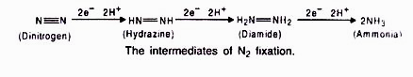

Assimilation of Ammonia:
The ammonia produced by nitrogenase is immediately protonated to form ammonium ion (NH₄+). As NH4⁺ is toxic to plants, it is rapidly used near the site of generation to synthesize amino acids. Amino acids synthesis takes place by three methods: reductive animation, catalytic amination and transamination.
(i) Reductive amination:
In this process, glumate dehydrogenase (GDH) catalyzes the synthesis of glutamic acid.
(ii) Catalytic amidation:
It is a two step process catalyzed by glutamine synthetase (GS) and glutamate synthetase (glutamine – 2-oxyglutarate aminotransferase, or GOGAT).
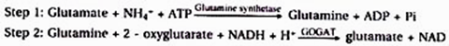
Out of the two glutamates produced one returns to GS while the other is exported to the plant.
(iii) Transamination:
Glutamate or glutamic acid is the main amino acid from which other amino acids are derived through transamination. The enzyme aminotransferases (= transaminases) catalyze all such reactions. Transamination involves transfer of amino group from one amino acid to the keto group of keto acid.
Glutamate (amino donor) + Oxaloacetate (amino acceptor) → Aspartate (amino acid) + 2 oxyglutarate
In nitrogen fixing plants, the fixed nitrogen is exported in the form of amides (asparagines and glutamine) and Ureides (allantoin, allantoic acid and citrulline), from the nodules to other plant parts via xylem. Amides are formed from two amino acids, namely glutamic acid and aspartic acid, by replacing – OH part by another NH₂– radicle. Thus, amides contain more nitrogen than amino acids and are structural part of most proteins.

Nitrate Assimilation:
Nitrate cannot be utilized by plants as such. It is first reduced to ammonia before being incorporated into organic compounds. Reduction of nitrate occurs in two steps:
1. Reduction of nitrate to nitrite:
It is carried out by an inducible enzyme, nitrate reductase. The enzyme is a molybdoflavoprotein. It requires a reduced coenzyme NADH or NADPH for its activity which is brought in contact with nitrate by FAD or FMN.
2. Reduction of nitrate:
It is carried out by the enzyme nitrite reductase. The enzyme is a metalloflavoprotein which contains copper and iron. It occurs inside chloroplast in leaf cells and leucoplast of other cells. Nitrite reductase require reducing power. It is NADPH and NADH (NADPH in illuminated cells).

Reduction process also require ferredoxin which occurs in green tissues of higher plants. It is presumed that in higher plants either nitrite is trans-located to leaf cells or some other electron donor (like FAD) operates in un-illuminated cells. The product of nitrite reduction in ammonia.
Ammonia thus produced combines with organic acids to produce amino acids. Amino acids form protein by the process of translation.

Rhizobium: Important symbiotic nitrogen fixing bacteria:
Rhizobium: Many rhizobia (plural form), nitrogen fixing bacteria, live in a symbiotic relationship with plants known as legumes. They have an interesting strategy to deal with O₂. In plants infected with Rhizobium, (legumes such as alfalfa or soybeans), the presence of oxygen in the root nodules would reduce the activity of the oxygen-sensitive nitrogenase. In these situations, the roots of such plants produce a protein known as leghemoglobin (also leghaemoglobin or legoglobin). Leghemoglobin buffers the concentration of free oxygen in the cytoplasm of infected plant cells to ensure the proper function of root nodules. Leghemoglobin is a nitrogen or oxygen carrier; naturally occurring oxygen and nitrogen interact similarly with this protein. Leghemoglobin buffers the concentration of free oxygen in the cytoplasm of infected plant cells to ensure the proper function of root nodules. It has close chemical and structural similarities to hemoglobin, and, like hemoglobin, is red in colour. Leghemoglobin has a high affinity for oxygen, about ten times higher than of human hemoglobin. This allows an oxygen concentration that is low enough to allow nitrogenase to function but not so high as to bind all the O₂ in the bacteria, providing the bacteria with oxygen for respiration.
Leghemoglobin is produced by legumes in response to the roots being infected by rhizobia, as part of the symbiotic interaction between the plant and these nitrogen-fixing bacterium. Interestingly, it is widely believed that leghemoglobin is the product of both the plant and the bacterium in which a protein precursor is produced by the plant and the heme (an iron atom bound in a porphyrin ring, which binds O₂) is produced by the bacterium. The protein and heme come together to function, allowing the bacteria to fix-nitrogen, giving the plant usable nitrogen and thus the plant provides the rhizobia a home.

