Sexual Reproduction in Oedogonium

The sexual reproduction in Oedogonium is of advanced oogamous type. Male and the female gametes differ morphologically as well as physiologically. The male gametes are produced in antheridia and the female gametes are produced in oogonia.
The factors influencing sexual reproduction are alkaline medium, deficiency of nutrition, light and dark periods and increased temperature.
Depending upon the nature of antheridia producing plants, Oedogonium species are of two types:

(i) Macrandrous:
If antheridia are produced on normal size plant, Oedogonium forms are called macrandrous. Macrandrous species may be monoecious or dioecious. In monoecious macrandrous species antheridia and oogonia are produced on the same plant e.g., O. fragile, O. hirnii, O. nodulosum etc. In dioecious macrandrous species antheridia and oogonia are produced on separate male and female plants of normal size.
(ii) Nannandrous:
The female or oogonia bearing plants are normal. The antheridia are produced on special type of small or dwarf plants, known as Dwarf males or Nannandria. The dwarf males are formed by androspores which are produced in androsporangia.
If androsporangia and oogonia are formed on same plant, the Oedogonium forms are called gynandrosporous e.g., O. concatinatum. If androsporangia and oogonia are formed on different plants, Oedogonium forms are called idioandrosporous e.g., O. confertum, O. iyengarii and O. setigerum. According to some algologists, nannondrous species are more primitive.

Antheridia:
(i) In macrandrous forms:
The antheridia develop on normal filaments, terminal or intercalary in position. The initial cell which gives rise to antheridia is called antheridial mother cell. It is normally a cap cell. The antheridial mother cell divides by transverse division to form an upper smaller cell called antheridium and a lower larger cell called sister cell.
The sister cell divides repeatedly to form a row of 2-40 antheridia (Fig. 6 A). The antheridia are broad, flat, short cylindrical, uninuleate cells. The contents of an antheridial cells divide either longitudinally or transversely into two and each metamorphoses into an antherozoid.
The two antherozoids are positioned side-by-side or one above the other if divisions are longitudinal and transverse respectively. The antherozoids are liberated in the same fashion as zoospores (Fig. 6 B). The liberated antherozoids are pale green or yellow green, oval or pear shaped.
Antherozoids are motile, about 30 sub-apical flagella present at the base of beak or hyaline spot (Fig. 6 C). They swim freely in water before they reach oogonia and take part in fertilization. The antherozoids are similar to zoospores in structure but these are smaller than zoospores.
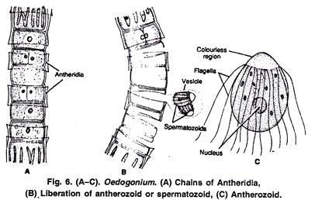

(ii) In nannandrous forms:
The antheridia are formed on short or dwarf male plants called dwarf males or nannandria (Fig. 7 G). The dwarf male filament is produced by the germination of a special type of spore known as androspore.
The androspore is produced singly within an androsporangium. Androporangia are more or less similar looking to the antheridia of macrandrous forms and are produced in a similar manner from a mother cell (Fig. 7 A, B).
The androsporangia are flat, discoid cells slightly larger than antheridia. Each androsporangium produces a single androspore just as in the case of zoospore. Liberation of androspore is similar to that of a zoospore. The androspores look similar to zoospore except for the smaller size. The androspores are motile and have a subpolar ring of flagella.
After swimming about for some time, the androspore settles on oogonial wall e.g., O. ciliatum or on the supporting cell e.g., O. concatenatum. The androspore germinates into a dwarf male or nannandrium. Germlings at one celled stage may divide and produce two antherozoids e.g., O. deplandrum, O. perspicuum (Fig. 7 C-G).
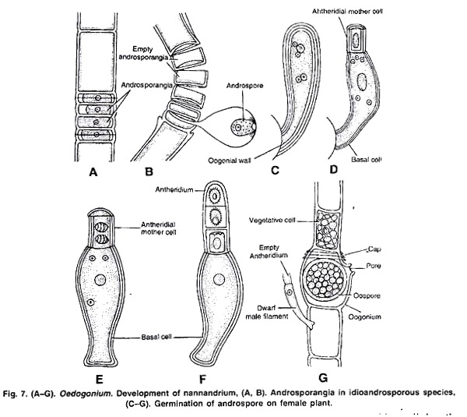

The nannandrium or dwarf male can be a few cells long. It has a basal attaching cell the stipe and all other cells are antheridial cells. Protoplasm of each antheridial cell divides to form two antherozoids which are similar to antherozoids of macrandrous species.
According to Iyengar (1951) the antheridium of nannandrium produces single antherozoid. The antherozoids are released by disorganization of antheridial cell or through the opening. Pascher considered the nanandrous forms as primitive and macrandrous as specialized but a large number of phycologists consider that nannandrous species have been evolved from macrandrous species.

Oogonia:
In Oedogonium the female sex organ oogonia are highly differentiated female gametangia. These are mostly intercalary but sometimes can be terminal e.g., O. palaiense.
The structure and development of oogonium is identical in macrandrous and nannandrous species. Like antheridia any freely divided or actively growing cap cell functions as the oogonial mother cell. The oogonial mother cell divides by transverse division into two unequal cells, the upper cell and the lower cell.
The upper larger cell forms oogonium and the lower smaller cell function as supporting cell or suffultory cell. In some species the oogonial mother cells directly forms the oogonium. Supporting cell is absent is O. americanum.
In monoecious species the suffultory cell may divide to form antheridia. The upper cell contains more cytoplasm, food and enlarges into spherical or flask shaped oogonium. The oogonium also secretes growth hormones which induce suffultory cell to increase in size (Fig. 8 A-C).
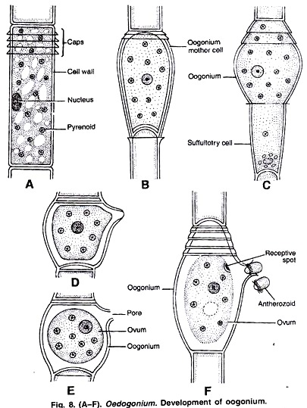

The protoplast in oogonium metamorphoses into a single egg or ovum. The ovum is non-motile, green due to chlorophyll and has a central nucleus. As the ovum matures, the nucleus moves to periphery, the oosphere retracts slightly from the oogonial wall and develops a hyaline or receptive spot just outside the nucleus. The receptive spot receives antherozoids for fertilization.
At receptive spot a pore is formed by gelatinization of wall . In some species a mucilage drop is extruded through opening to attract antherozoids.
In macrandrous monoecious species, where antheridia and oogonia develop on the same plant, the Oedogonium species are protogynous i.e., the development of oogonia takes place before development of antheridia to ensure cross-fertilization.
Fertilization:
The mature egg secretes chemical substance or mucilage to attract antherozoids or the antherozoids may enter oogonium through the slit. The antherozoids swim through the opening of oogonial wall and enter the egg through hyaline receptive spot (Fig. 8 D-F). Only one male antherozoid is able to fuse with ovum.
After plasmogamy and karyogamy the male nucleus and female nucleus fuse to form a diploid zygote nucleus. The zygote secretes a thick wall around itself and forms oospore. The colour of the oospore changes from green to reddish brown. The oospore is liberated by the disintegration of oogonial wall.
Germination of oospore:
Oospore is a resting spore but sometimes it can germinate directly. The period of rest for oospore may be a year or more.
According to Mainx (1931) the zygote may require chilling before germination. The diploid oospore divides meiotically to form four haploid daughter protoplasts. Each daughter protoplast metamorphosis into a zoospore also called as zoomeiospore.
The zoomeiospores are liberated in a vesicle (Fig. 9 A). Soon the vesicle disappears and as in asexual reproduction the zoospores develop to form Oedogonium plants.
In some cases out of four nuclei a few may degenerate forming less than four zoomeiospores. In heterothallic forms e.g., O. plagiostomum, out of four two give rise to male and the two give rise to female plants.
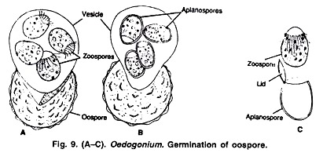

In Oedogonium the thallus is haploid and the life cycle is haplontic type. The diploid stage in life cycle is only zygote. It occurs for a short period. The zygote or oospore undergoes meiosis to make four meiozoospores which again form haploid Oedogonium thalli.

