Experiment 1: To draw the characteristics of vacuum diode valve

Structure

  - Objectives

  - Introduction

  - Apparatus Used

  - Theory and Formula Used

  - About apparatus

  - Procedure

  - Observation

  - Calculation and Discussion

  - Result

  - Precaution and source of error

  - Summary

  - Glossary

  - References

  - Viva-voce questions and Answers

Object:
After performing this experiment, you should be able to

    - What are vacuum tubes specially diode
    - Working of diode
    - How characteristics of diode valve is drawn

Introduction:
Diode valve is a vacuum tube having two electrodes namely plate and cathode inside evacuated glass tube. It works on the principle of thermionic emission. For the proper use of the diode valve plate is kept at high potential with respect to cathode. When cathode of diode is heated by passing current in it, the cathode emits electrons. These electrons are collected by plate, which is at positive potential with respect to cathode. Electrons flow from cathode to plate, thus plate current flows in plate circuit. As plate voltage increases the plate current also increase. The current in circuit is controlled by plate and grid potentials. The plate current flows in the circuit only when plate is positive potential with respect to cathode and direction of flow of electron is always from cathode to plate never plate to cathode. Because of this unidirectional flow of current, diode is called ‘diode valve’.

At constant temperature of cathode the variation of plate current with the plate voltage is non linear and plate current is controlled by space charge. The current is called space charge limited current. When the temperature of cathode is increased, more electrons are emitted from cathode hence increase in saturated plate current .

Apparatus Used:
The diode valve, 6.3 volt heating filament (cathode), high tension source for plate (around 250V), voltmeter (0-250V) , milliammeter (0-10 mA) and Rheostat (100Ω), connection wires.

Theory and Formula Used:
Diode valve is two electrode namely plate and cathode. When cathode of the diode valve is heated, the electrons are emitted from the surface of cathode. The number of electrons emitted depends on temperature of the cathode. The first group of emitted electrons gathers in the space surrounding the cathode. It exerts repealing electrostatic force to next emitted electrons, which therefore start to return to cathode. Their return is however prevented by next group of emitted electrons. Thus the dense cloud of electron is formed in space around cathode. This electron cloud is called space charge. This space charge repeals the further emitted electron. When plate is given small positive potential, some of the electrons near the plate is attracted by plate and constitute current. If we further increase plate potential, the plate current also increases.

This current only depends on space charge, plate potential and independent of temperature of cathode. When plate voltage is increased, the plate current also increases. This variation is not linear, and current is called space limited plate current. If the plate voltage is further increases,

the current become maximums
called saturated current. This happens when
plate voltage is

enough high to attract all electrons emitted by cathode. At this stage, the saturated current can only increased by increasing temperature of cathode. This saturated current is called temperature limited current.

About apparatus:

Diode valve is a vacuum tube having two electrodes namely plate and cathode inside evacuated glass tube as shown in figure 1. Cathode, which serve as source of electrons is an indirectly heated oxide-coated nickel cylinder. Cathode is heated indirectly by insulated heater filament enclosed within it. The plate is also hollow cylinder made of nickel, molybdenum or iron and surrounds the cathode.
The apparatus in the experiment is a simple electric circuit as shown in figure 2. The triode valve have three electrode 6V battery is connected to the electric bulb with rheostat. For the measurement of current and voltage the DC Voltmeter (0-10V) & DC ammeter (0-1 A) are connected.

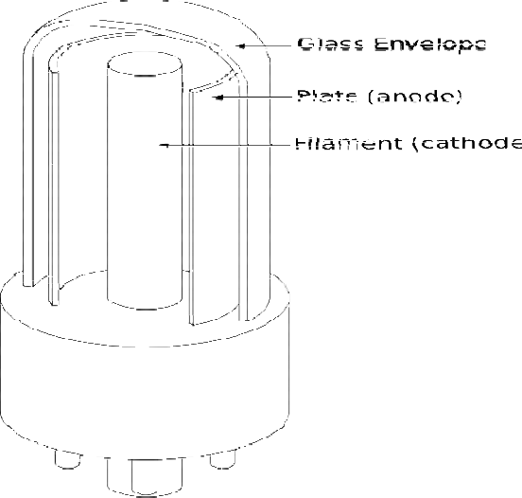
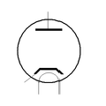

Figure 1

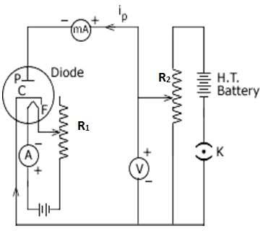

Figure 2

Procedure:
For plate characteristics, perform the experiment in following steps.
- Make electrical connection as shown in figure 2.
- With the help of rheostat R₂ adjust to minimum plate voltage.
- Note down the plate current in milliamter.
- Now increase the plate potential in the steps (say in 2V step) and read the corresponding plate current in milliamter.
- Draw the graph between plate voltage and plate current, which is called plate characteristics of diode.

Summary:
  - A vacuum diode is a device which works on the principle of thermionic emission.
  - Diode has two electrode namely plate cathode.
  - There is unidirectional flow of current i.e. from plate to cathode.
  - When plate potential increases, the plate current also increase.
  - Plate current is of order milliampares flows in circuit.

`

Viva-voce questions:
Question1. Define the process of thermionic emission?
Answer: When metal filament is heated, it emits electron from its surface. The phenomenon of emission of electrons by heating is called thermionic emission.
Question2. Why the diode is called diode valve?
Answer: The device is called diode as there are two electrodes namely plate and cathode. The flow of current in the device is unidirectional from plate to cathode. The current flows when plate is positive potential with respect to cathode, not when plate is negative potential with respect to cathode.
Question3. Define space charge?
Answer. When cathode of diode valve is heated, the electron emitted from surface of cathode. These emitted electrons make cloud in space between cathode and plate and they repeal the further emitted electron from cathode. This cloud of negatively charged is called space charge.
Question4. What is the use of diode valve?
Answer: Diode valve is used in rectification i.e. it covert AC signal to DC signal.
Question5. What is saturated current and how it is increased?

Answer: On increasing plate voltage the plate current increase. But when plate voltage is sufficient high to attract all the electrons emitted by cathode i.e. rate of emission of electrons by cathode is equals the rate of attraction of electrons by plate, the plate current does not change by change of plate voltage. This maximum current is called saturated current. The saturated current can be increased by increasing temperature of cathode as that more electrons are available to flow.

