Cyanophyceae:

Important Characteristics of Cyanophyceae:
The important characteristics of the division are as follows:
1. The individual cells are prokaryotic in nature. The nucleus is incipient type and they lack membrane bound organelles.
2. Both vegetative and reproductive cells are non-flagellate.
3. Cell wall is made up of microfibrils and is differentiated into four (4) layers. The cell wall composed of mucopeptide, along with carbohydrates, amino acids and fatty acids.
4. Locomotion is generally absent, but when occurs, it is of gliding or jerky type.
5. The principal pigments are chlorophylls a (green), c-phycocyanin (blue) and c-phyco- erythrin (red). In addition, other pigments like β-carotene and different xanthophylls like myxoxanthin and myxoxanthophyll are also present.
6. Membrane bound chromatophore are absent. Pigments are found embedded in thylakoids.
7. The reserve foods are cyanophycean starch and cyanophycean granules (protein).
8. Many filamentous members possess specialized cells of disputed function (supposed to be the centre of N₂ fixation) known as heterocysts.
9. Reproduction takes place by vegetative and asexual methods. Vegetative reproduction takes place by cell division, fragmentation etc. Asexual reproduction takes place by endospores, exospores, akinetes, nannospores etc. Sexual reproduction is completely absent.

Distribution of Cyanophyceae:
Members of Cyanophyceae are available in different habitats. Most of the species are fresh water (e.g., Oscillatoria, Rivularia), a few are marine (e.g., Trichodesmium, Darmocarpa), and some species of Oscillatoria and Nostoc are grown on terrestrial habitat. Species of some members like Anabaena grow as endophytes in thallus of Anthoceros (Bryophyta) and in leaves of Azolla (Pteridophyta) and Nostoc in the root of Cycas (Gymnosperm). Species of Nostoc, Scytonema, Gloeocapsa, and Chroococcus grow symbiotically with different fungi and form lichen. Some members like Nostoc, Anabaena etc. can fix atmospheric nitrogen and increase soil fertility.

Thallus Organisation in Cyanophyceae:
Plants of this group show much variation in their thallus organisation.
The thallus may be of unicellular or colonial forms:
1. Unicellular Form:
In unicellular form, the cells may be oval or spherical. Common members are Gloeocapsa (Fig. 3.23A), Chroococcus and Synechococcus.
2. Colonial Form:
In most of the members the cells after division remain attached by their cell wall or remain together in a common gelatinous matrix, called a colony.
The colonies may be of two types:
a. Non- filamentous, and
b. Filamentous.

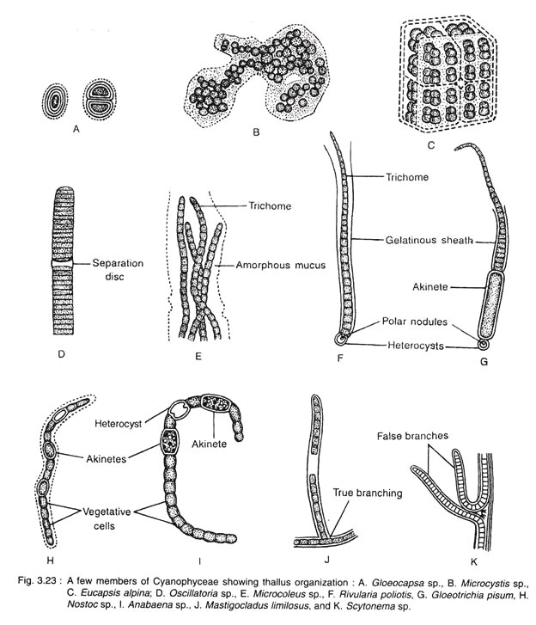
a. Non-Filamentous Type:
The cells of this type divide either alternately or in three planes, thereby they form spherical (Gomphosphaera, Coelosphaerum), cubical (Eucapsis alpine), squarish (Merismopedia) or irregular (Microcystis) colony.
b. Filamentous Type:
By the repeated cell division in one plane, single row of cells are formed, known as trichome. e.g., Oscillatoria, Spirulina, Arthosporia etc. The trichome when covered by mucilaginous sheath is called a filament. The filament may contain single trichome (Oscillatoria, Lyngbya) or several trichomes (Hydrocoleus, Microcoleus). The trichomes may be unbranched (Oscillatoria, Lyngbya), branched (Mastigocladus limilosus) and falsely branched (Scytonema and Tolypothrix).

