**PRESENTATION OF THE CLASS C AMPLIFICATION**

[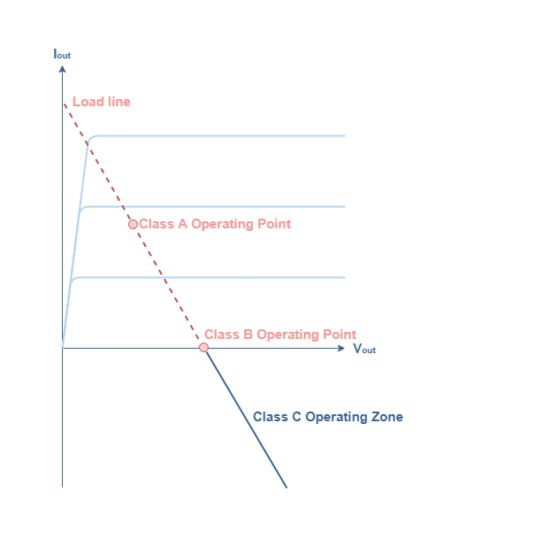](https://www.electronics-lab.com/wp-content/uploads/2019/09/ClassC_1.png)

fig 1 : Operating zone of class C amplifiers

Since this operating zone extends beyond the class B operating point, which represents a 78.5 % efficiency and a 180° conduction angle, class C amplifiers are therefore characterized by a very high efficiency between **78.5 % and 100 %**as we will detail more in the third section. Moreover, their conduction angle is very low, between **0° and 180°**, which means that they conduct less than half of the signal. As we will see later on, it is precisely this fact that makes them non linear.

Class C amplifiers are mostly used for high frequency applications, they generate many harmonics that must be filtrated in order to faithfully reproduce the input signal. This filtration can be done for example with an **RLC circuit**as presented in the **Figure 2** that represents the basic structure of class C amplifiers :

[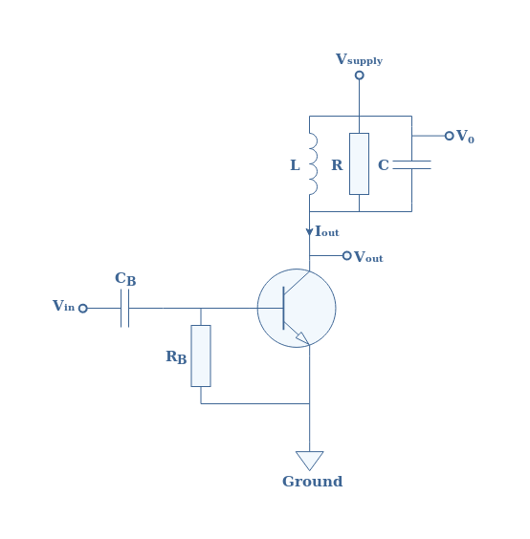](https://www.electronics-lab.com/wp-content/uploads/2019/09/ClassCp2.png)

fig 2 : Basic structure of a class C amplifier

The aim of the RLC circuit, also known as “circuit stopper” is to eliminate the undesired frequencies and to only keep the fundamental frequency f1 of the input signal.

In practice, the load is coupled to the resonant circuit with a transformer as presented in **Figure 3**.

[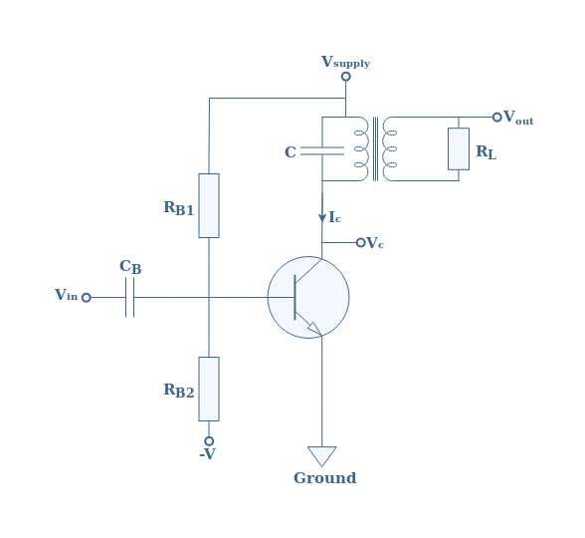](https://www.electronics-lab.com/wp-content/uploads/2019/09/ClassCp3.png)

fig 3 : Transformer-coupled class C amplifier

As already presented during the [class A amplifier tutorial](https://www.electronics-lab.com/article/class-a-amplifiers/), this transformer-coupled configuration ensures that the load is isolated from the power supply and it is also used to realize an impedance matching. Moreover, the base is biased through a voltage divider network. In the following section, we will always refer to the **Figure 3** circuit.

[https://www.electronics-lab.com/wp-content/uploads/2019/09/ClassCp4-6.png](https://www.electronics-lab.com/wp-content/uploads/2019/09/ClassCp4-6.png)fig 4 : Graphical representation of the output current

As we can see from **Figure 4**, the output current can be described as “pulsed”. It can be characterized by two important parameters : the peak current **ICM** and the**δ** values that delimits the pulse signal. It is interesting to note that the conduction angle is equal to **2δ** and represents the electrical angle in which the output current is not equal to zero.

If the output stage of the class C amplifiers does not have a circuit stopper but only a load, both the current and voltage are pulsed such as shown in **Figure 4**, this functioning mode is called the **untuned mode**. As explained more in detail in the last section, a proper choice of the value of the product L×C can lead to a functioning mode in **tuned mode**. In this mode, a particular frequency of the pulses is filtrated by the RLC circuit in order to regenerate the sine of the input signal, therefore performing a faithful amplification.

If we consider the input signal to be of the form **Vin(t)=VI×sin(2πf1t)**, an important formula can be given in **Equation 1**and links the maximal value of the output current ICM to the amplitude of the input signal VI:

[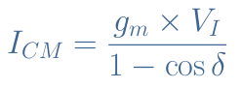](https://www.electronics-lab.com/wp-content/uploads/2019/09/eqICM.png)eq 1 : Expression of the maximal value of the output current

From this equation, we can understand that the conduction angle influences greatly the amplification process. The graph below represents the evolution of ICM for a conduction angle in the class C interval ]0° ; 180°[, that is to say for a δ value in the range ]0° ; 90°[.

[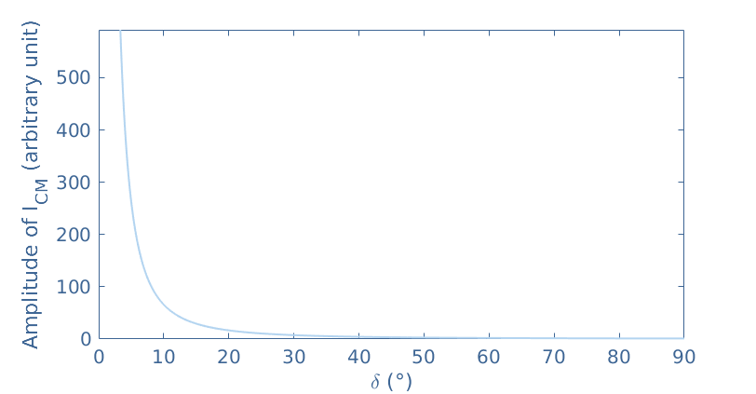](https://www.electronics-lab.com/wp-content/uploads/2019/09/figmatlab-2.png)fig 5 : ICM=f(δ). Plotted with MatLab®

We can clearly note a fast decrease of the maximal value of the output current when the conduction angle increases. This graph gives an overview of the efficiency of the class C configuration : the smaller the conduction angle, the higher the output current.

In the tuned functioning mode, the output voltage can simply be written under the form **Vout=Vsupply+k.Vsupply×sin(2πf1t+π).**It is amplified by a factor k.Vsupply, phase shifted of π rad and presents an offset equal to Vsupply. Note that **k** is called the transformer coupling factor and is in the range [0;1]. This factor highlights the quality of the transformer used, for example a perfect transformer has a coupling factor of 1.

**EFFICIENCY OF CLASS C AMPLIFIERS**

The method and steps to demonstrate the formula of efficiency **η** for class C amplifiers involves integral calculus and is not shown in this tutorial. The formula linking the efficiency to the parameters **δ** and **k** is given in the **Equation 2**below :

[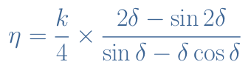](https://www.electronics-lab.com/wp-content/uploads/2019/09/eqeta-2.png)

eq 2 : Efficiency of a class C amplifier

It is interesting to visualize the dependency of the efficiency on both parameters in a graph given below :