**Dr. Rima Kumari: Date: 25/09/2020**

Online class and e- content for BSc IIIrd year students

|  |  |  |
| --- | --- | --- |
| Date and Time | Online class medium | E. content topic |
| 25/09/2020  01:00 p.m to 1.35 p.m | Via Google meet  Link: Meeting URL: https://meet.google.com/apt-mrot-bgd | 1. **Virus structure** 2. **Difference between Eukaryotes and Prokaryotes:** |

**Virus structure**

**Viruses:** Viruses are on the borderline of life between non-living and the living organisms. They have some characteristics of a living organism such as the ability to reproduce while some of non-living objects, like the absence of metabolic processes and ability to crystallise. Viruses are very simple organisms with a circular nucleic acid molecule **(DNA** or **RNA)** surrounded by a protein coat. **Viruses are** organisms **which live only as** parasites and can reproduce themselves only in a host **cell such** as **bacteria, animals or plants at the expense of the** metabolic machinery **of the** **host cell.**

Certain viruses contain ribonucleic acid (RNA), while other viruses have deoxyribonucleic acid (DNA). The nucleic acid portion of the viruses is known as the genome. The nucleic acid may be single-stranded or double-stranded; it may be linear or a closed loop; it may be continuous or occur in segments. The genome of the virus is surrounded by a protein coat known as a capsid, which is formed from a number of individual protein molecules called capsomeres. Capsomeres are arranged in a precise and highly repetitive pattern around the nucleic acid. A single type of capsomere or several chemically distinct types may make up the capsid. The combination of genome and capsid is called the viral nucleocapsid.

A number of kinds of viruses contain envelopes. An envelope is a membrane like structure that encloses the nucleocapsid and is obtained from a host cell during the replication process. The envelope contains viral-specified proteins that make it unique. Among the envelope viruses are those of herpes simplex, chickenpox, and infectious mononucleosis.

Enveloped viruses have membranes surrounding capsids. Animal viruses, such as HIV, are frequently enveloped. Head and tail viruses infect bacteria. They have a head that is similar to icosahedral viruses and a tail shape like filamentous viruses.



**T1** bacteriophage (bacteriophage Is a specltic type **of virus** which kills bacteria). Six tail flbres and collar whiskers are shown in the diagram.

Viruses are boarder link between non-cellular and cellular elements that use a living cell for their replication and inactive (non living) in extracellular state. Viruses are ultramicroscopic particles containing nucleic acid surrounded by protein, and in some cases, other macromolecular components such as a membranelike envelope. A virion is complete viral structure consists of a nucleic acid core, an outer protein coating or capsid. The capsid is made up of protein subunits called capsomeres. Sometimes an outer envelope made of protein and phospholipid membranes derived from the host cell.

**Difference between Eukaryotes and Prokaryotes:**

|  |  |  |
| --- | --- | --- |
| **Nucleus** | Present | Absent |
| **Number of chromosomes** | More than one | not true chromosome, Plasmids |
| **Cell Type** | Usually multicellular, some unicellular | Usually unicellular (some cyanobacteria may be multicellular) |
| **True Membrane bound Nucleus** | Present | Absent |
| **Example** | Animals and Plants | [Bacteria and Archaea](https://www.diffen.com/difference/Archaea_vs_Bacteria) |
| **Genetic Recombination** | Meiosis and fusion of gametes | Partial, undirectional transfers [DNA](https://www.diffen.com/difference/DNA_vs_RNA) |
| **Lysosomes and peroxisomes** | Present | Absent |
| **Microtubules** | Present | Absent or rare |
| **Endoplasmic reticulum** | Present | Absent |
| **Mitochondria** | Present | Absent |
| **Cytoskeleton** | Present | May be absent |
| **DNA wrapping on proteins.** | Eukaryotes wrap their DNA around proteins called histones. | Multiple proteins act together to fold and condense prokaryotic DNA. Folded DNA is then organized into a variety of conformations that are supercoiled and wound around tetramers of the Histone protein. |
| **Ribosomes** | larger | smaller |
| **Vesicles** | Present | Present |
| **Golgi apparatus** | Present | Absent |
| **Chloroplasts** | Present (in plants) | Absent; chlorophyll scattered in the cytoplasm |
| **Flagella** | Microscopic in size; membrane bound; usually arranged as nine doublets surrounding two singlets | Submicroscopic in size, composed of only one fiber |
| **Permeability of Nuclear Membrane** | Selective | not present |
| **Plasma membrane with steroid** | Yes | Usually no |
| **Cell wall** | Only in plant cells and fungi (chemically simpler) | Usually chemically complex |
| **Vacuoles** | Present | Present |
| **Cell size** | 10-100um | 1-10um |

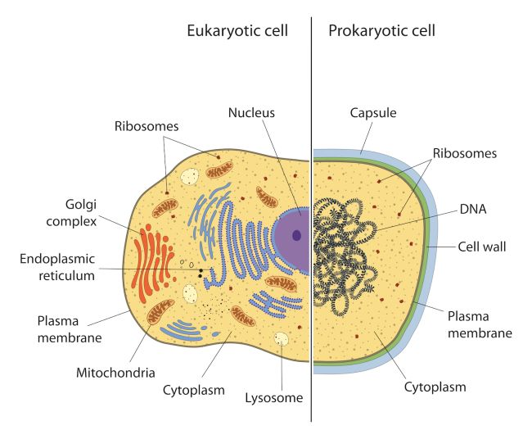

**Comparative difference in Prokaryote and Eukaryote**

The most fundamental difference is that eukaryotes do have "true" nuclei containing their DNA, whereas the genetic material in prokaryotes is not membrane-bound.

* In eukaryotes, the mitochondria and chloroplasts perform various metabolic processes and are believed to have been derived from endosymbiotic [bacteria](https://data.diffen.com/Bacteria). In prokaryotes similar processes occur across the cell membrane; endosymbionts are extremely rare.
* The cell walls of prokaryotes are generally formed of a different molecule (peptidoglycan) to those of eukaryotes (many eukaryotes do not have a cell wall at all).
* Prokaryotes are usually much smaller than eukaryotic cells.
* Prokaryotes also differ from eukaryotes in that they contain only a single loop of stable chromosomal DNA stored in an area named the nucleoid, while eukaryote DNA is found on tightly bound and organised chromosomes. Although some eukaryotes have satellite DNA structures called plasmids, these are generally regarded as a prokaryote feature and many important genes in prokaryotes are stored on plasmids.
* Prokaryotes have a larger surface [area](https://www.diffen.com/difference/Area_vs_Perimeter) to volume ratio giving them a higher metabolic rate, a higher growth rate and consequently a shorter generation time compared to Eukaryotes.
* **Genes**
  + Prokaryotes also differ from eukaryotes in the structure, packing, density, and arrangement of their genes on the chromosome. Prokaryotes have incredibly compact genomes compared to eukaryotes, mostly because prokaryote genes lack introns and large non-coding regions between each gene.
  + Whereas nearly 95% of the human genome does not code for proteins or [RNA](https://www.diffen.com/difference/DNA_vs_RNA) or includes a gene promoter, nearly all of the prokaryote genome codes or controls something.
  + Prokaryote genes are also expressed in groups, known as operons, instead of individually, as in eukaryotes.
  + In a prokaryote cell, all genes in an operon(three in the case of the famous lac operon) are transcribed on the same piece of RNA and then made into separate proteins, whereas if these genes were native to eukaryotes, they each would have their own promoter and be transcribed on their own strand of mRNA. This lesser degree of control over gene expression contributes to the simplicity of the prokaryotes as compared to the eukaryotes.

**Cell Walls**: Most prokaryotic cells have a rigid cell wall that surrounds the plasma membrane and gives shape to the organism. In eukaryotes, vertebrates don't have a cell wall but plants do. The cell walls of prokaryotes differ chemically from the eukaryotic cell walls of plant cells, which are primarily made of cellulose. In bacteria, for example, the cell walls are composed of peptidoglycans

**Nucleus/DNA**: Eukaryotic cells have a nucleus surrounded by a nuclear envelope that consists of two lipid membranes. The nucleus holds the eukaryotic cell's [DNA](https://www.livescience.com/37247-dna.html). Prokaryotic cells do not have a nucleus; rather, they have a membraneless nucleoid region. he entire DNA in a cell can be found in individual pieces known as chromosomes. Eukaryotic cells have many chromosomes which undergo meiosis and mitosis during cell division, while most prokaryotic cells consist of just circular DNA structure.

**Organelles in Eukaryotic Cells:** Eukaryotic cells have several other membrane-bound organelles not found in prokaryotic cells. These include the mitochondria (convert food energy into adenosine triphosphate, or ATP, to power biochemical reactions); rough and smooth endoplasmic reticulum (an interconnected network of membrane-enclosed tubules that transport synthesized proteins); golgi complex (sorts and packages proteins for secretion); and in the case of plant cells, chloroplasts (conduct photosynthesis). All of these organelles are located in the eukaryotic cell's cytoplasm

**Ribosomes**: In eukaryotic cells, the ribosomes are bigger, more complex and bound by a membrane. They can be found in various places: Sometimes in the cytoplasm; on the endoplasmic reticulum; or attached to the nuclear membrane (covering on the nucleus). In prokaryotic cells, the ribosomes are 70 S sub-unit scattered and floating freely throughout the cytoplasm. In eukaryotes, both 70S and 80 S sub unit of ribosomes present.

**Reproduction**: Most eukaryotes reproduce sexually (although some protists and single-celled fungi may reproduce through mitosis, which is functionally similar to asexual reproduction). Prokaryotes reproduce asexually, resulting in the offspring being an exact clone of the parent. Some prokaryotic cells also have pili, which are adhesive hair-like projections used to exchange genetic material during a type of sexual process called conjugation. Conjugation can occur in bacteria, protozoans and some algae and fungi.