Dr. Rima Kumari: Date: 23/09/2020
Online class and e- content for BSc IInd year students
Date and Time | Online class medium | E. content topic
23/09/2020  01:00 p.m to 1.40 p.m | Via Google meet  Link: Meeting URL: https://meet.google.com/gfx-uryp-wyv | Role of Microbes in Biological nitrogen fixation

Role of Microbes in Biological nitrogen fixation

Mainly two main types of microorganism involved in biological nitrogen fixation:
- Free-living (non-symbiotic) Nitrogen Fixing bacteria
- Symbiotic Nitrogen Fixing bacteria

Non-symbiotic bacteria:
- Free-living (non-symbiotic) Nitrogen Fixing bacteria Azotobacter, Beijerinckia (bothaerobic) and Clostridium (anaerobic) are saprophytic bacteria that perform nitrogen fixation. Desulphovibrio is chemotrophic nitrogen fixing bacterium. Rhodopseudomonas, Rhodospirillum and Chromatium are nitrogen fixing photoautotrophic bacteria. These bacteria add up to 10-25 kg, of nitrogen/ha/annum. Free-living (non-symbiotic) Nitrogen Fixing cyanobacteria Many free living blue-green algae (now called cyanobacteria) perform nitrogen fixation, e.g., Anabaena, Nustoc, Aulosira, Cylmdrospermum, Trichodesmium. These are also important ecologically as they live in water-logged sods where denitrifing bacteria can be active. Aulosira fertilissima is the most active nitrogen fixer in Rice fields, while Cylindrospermum is active in sugarcane and maize fields. They add 20-30 kg Nitrogen/ha/annum.

Symbiotic bacteria:
Symbiotic Nitrogen Fixing bacteria
Rhizobium is aerobic, gram negative nitrogen fixing bacterial symbionts of Leguminaceae roots. Several species of Rhizobium live in the soil but are unable to fix nitrogen by themselves. They do so only as symbionts in the association of roots of legumes. Sesbania rostrata has Rhizobium in root nodules and Aerorhizobium in stem nodules. Frankia is symbiont in root nodules of many non-leguminous plants like Casuarina and Alnus. Xanthomonas and Mycobacterium occur as symbiont in the leaves of some members of the families Rubiaceae and Myrsinaceae (e.g., Ardisia). Frankia, associated with certain dicotyledonous species (actinorhizal plants); and certain Azospirillum species, associated with cereal grasses.
Symbiotic Nitrogen Fixing cyanobacteria
Anabaena and Nostoc species are common symbionts in lichens, Anthoceros, Azolla and cycad roots. Azolla pinnata (a water fern) has Anabaena azollae in its fronds. It is often inoculated to Rice fields for nitrogen fixation.
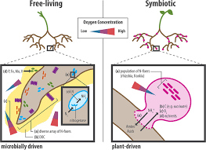

Symbiotic Nitrogen Fixation:
Both Rhizobium sp. and Frankia are free living in soil, but only as symbionts, can fix atmospheric di-nitrogen. The symbiotic nitrogen-fixing bacteria invade the root hairs of host plants, where they multiply and stimulate the formation of root nodules, enlargements of plant cells and bacteria in intimate association. Within the nodules, the bacteria convert free nitrogen to ammonia, which the host plant utilizes for its development. To ensure sufficient nodule formation and optimum growth of legumes (e.g., alfalfa, beans, clovers, peas, and soybeans), seeds are usually inoculated with commercial cultures of appropriate Rhizobium species, especially in soils poor or lacking in the required bacterium.
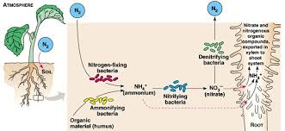

The symbiotic nitrogen fixation can be discussed under following steps:
(i) Nodule formation:
It involves multiple interactions between free-living soil Rizobium and roots of the host plant. The important stages involved in nodule formation are as follows-Host Specificity: A variety of microorganisms exist in the rhizosphere (i.e. immediate vicinity of roots) of host roots.
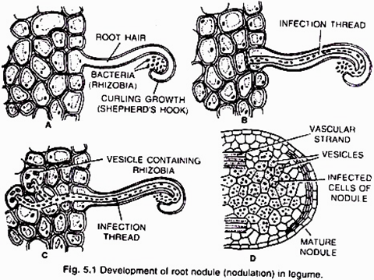
The roots of young leguminous plants secrete a group of chemical attractants like flavonoids and betaines. In response to these chemical attractants specific rhizobial Tells migrate towards the root hairs and produce nod (nodulation) factors. The nod factors found on bacterial surface bind to the lectin proteins present on the surface of root hairs. This lectinnod factor interaction induces growth and curling of root hairs around Rhizobia.
At these regions wall degrades in response to node-factors and Rhizobia enter the root hair invagination of plasma membrane called infection thread. The infection thread filled with dividing Rhizobia elongate through the root hair and later branched to reach different cortical cells.
The Rhizobia are released into the cortical cells either single or in groups enclosed by a membrane. The Rhizobia stop dividing, loose cell wall and become nitrogen fixing cells as led bacteroids .The membrane surrounding the bacteroids is called peribacteroid membrane. The infected cortical cells divide to form nodule (Fig. 5.2).
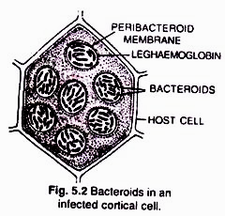

(ii) Mechanism of nitrogen fixation (Fig 5.3):
The nodule serves as site for N₂ fixation. It contains all the necessary bio-chemicals such as the enzyme complex called nitrogenase and leghaemoglobin (leguminous haemoglobin). The nitrogenase has 2 components i.e. Mo-Fe protein (molybdoferredoxin) and Fe-protein (azoferredoxin).The nitrogenase catalyzes the conversion of atmosphere di-nitrogen (N₂) to 2NH₃. The ammonia is the first stable product of nitrogen fixation.
The overall equation is:
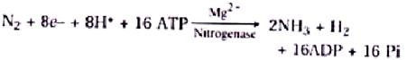

The nitrogenase is extremely sensitive to oxygen. To protect these enzymes, nodule contains an oxygen scavenger called leghaemoglobin (Lb), which is a reddish-pink pigment. There are two views about location of leghaemoglobin that is either located outside the peribacteroid membrane or located in between bacteroids.
During nitrogen fixation, the free di-nitrogen first bound to MoFe protein and is not released until completely reduced to ammonia. The reduction of di-nitrogen is a stepwise reaction in which many intermediates are formed to form ammonia (NH₃) which is protonated at physiological pH to form NH4+. In this process ferredoxin serves as an electron donor to Fe-protein (nitrogenase reductase) which in turn hydrolyzes ATP and reduce MoFe protein, the MoFe protein in Turn reduce the substrate N₂. The electrons and ATP are provided by photosynthesis and respiration of the host cells.
